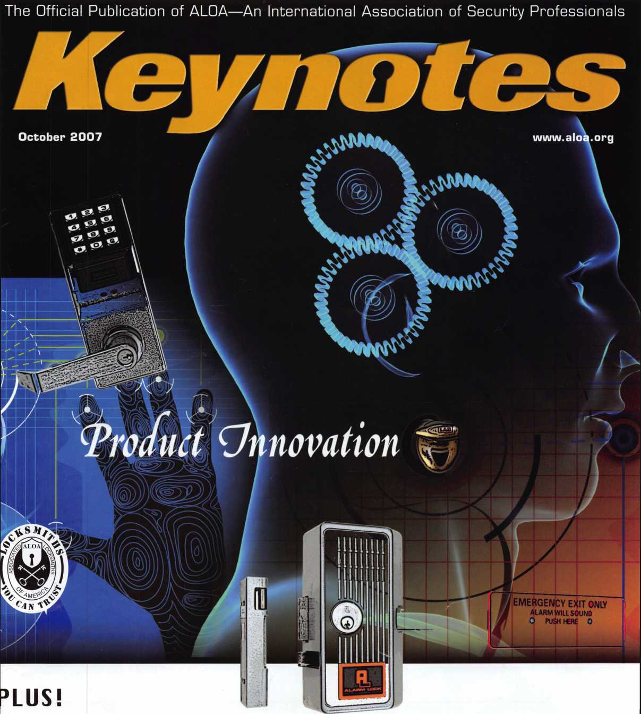

Ictober Member Spotlight JEW Membership Column

**ireg Perry asks Is** This Lock Too “Smart” For Us? **ind MORE!**

Breck H. Camp Cm]

PO Box 47070 Atlanta GA 30362-0070

liiililliiiiiil..llt...l.llliiiliiiiliiillliiiliiillliiiiilill

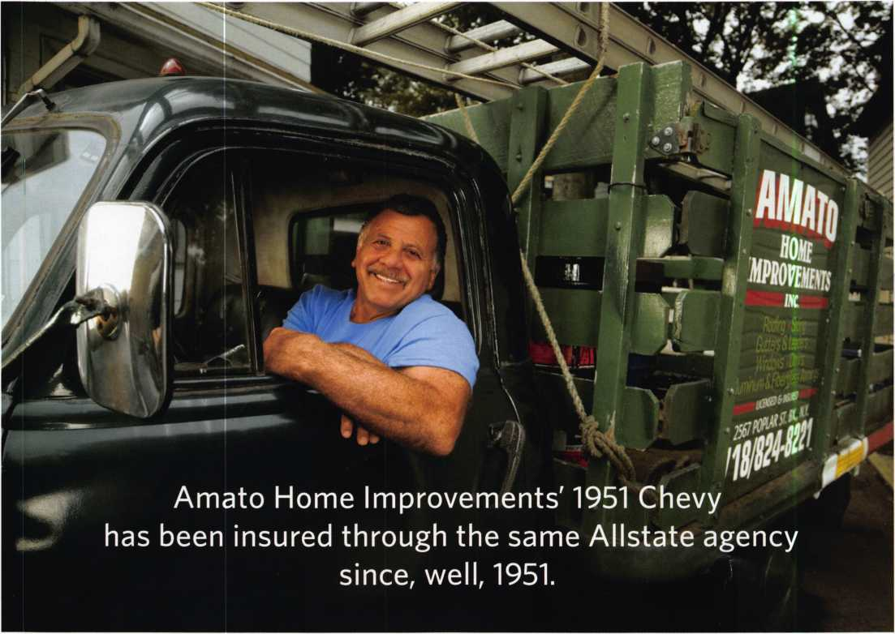

y

ears ago, Joe Amatos father  
bought a commercial vehicle

policy from Allstate Agent  
Ralph Borsella. Today, Ralph  
Bor sella, Jr., services the policy,  
and Joe runs the family business.  
Through many years and two  
generations, their business  
relationship is still going strong.  
Just like Joe's 551 Chevy.

**ALLSTATE AGENTS VALUE LONG-TERM  
CUSTOMERS AS MUCH AS YOU DO.**

Our agents understand the unique needs of business  
owners like you. Because they're business owners, too.  
They'll help you get the insurance that's right for your  
business at a competitive price. And if you need to file a  
claim, they'll help you get back on the road fast. When  
your livelihood relies on your vehicle, you need coverage  
you can rely on. That's Allstate's Stand!M

Call now to save on Allstate Commercial Vehicle Insurance.

FOR AN ALLSTATE AGENT NEAR YOU, CALL 1-888-322-3078

**#/instate**

You're in good hands.

***Auto Home Life Retirement***

Subject to availability and qualifications. Life insurance and annuities issued by Allstate Life Insurance Company, Northbrook, IL and Lincoln Benefit Life Company, Lincoln, NE. In New York, Allstate Life Insurance Company of New York, Hauppauge, NY. Property-casualty insurance products issued by Allstate Fire and Casualty Insurance Company, Allstate Indemnity Company, Allstate Insurance Company, Allstate Property and Casualty Insurance Company, Allstate County Mutual Insurance Company, Irving, TX and Allstate New Jersey Insurance Company, Bridgewater, NJ. © 2007 Allstate Insurance Company

**■Lb Flake Oo>**

Over 95 years of quality service

>>

ri .

TTI

*HAimo*

**DELIVERED** ON TIME!

FREE FREIGHT is just  
a small order away!

You are never more than 3 days away!

BUSINESS DAYS

**3 DAYS AWAY**

2 DAYS AWAY

FREE GROUND FREIGHT WITH:

L 1$ 95.00

I I $115.00

EHI $135.°° order

FREE FREIGHT

(excludes key machines, safes, & bulk key orders)  
(within contiguous 48 states)

OVER WEEKENDS, ADD 2 DAYS

**Please** know that if you **have** a preference on your delivery carrier, it may extend the delivery time of your package. The delivery time will not exceed 3 business days.

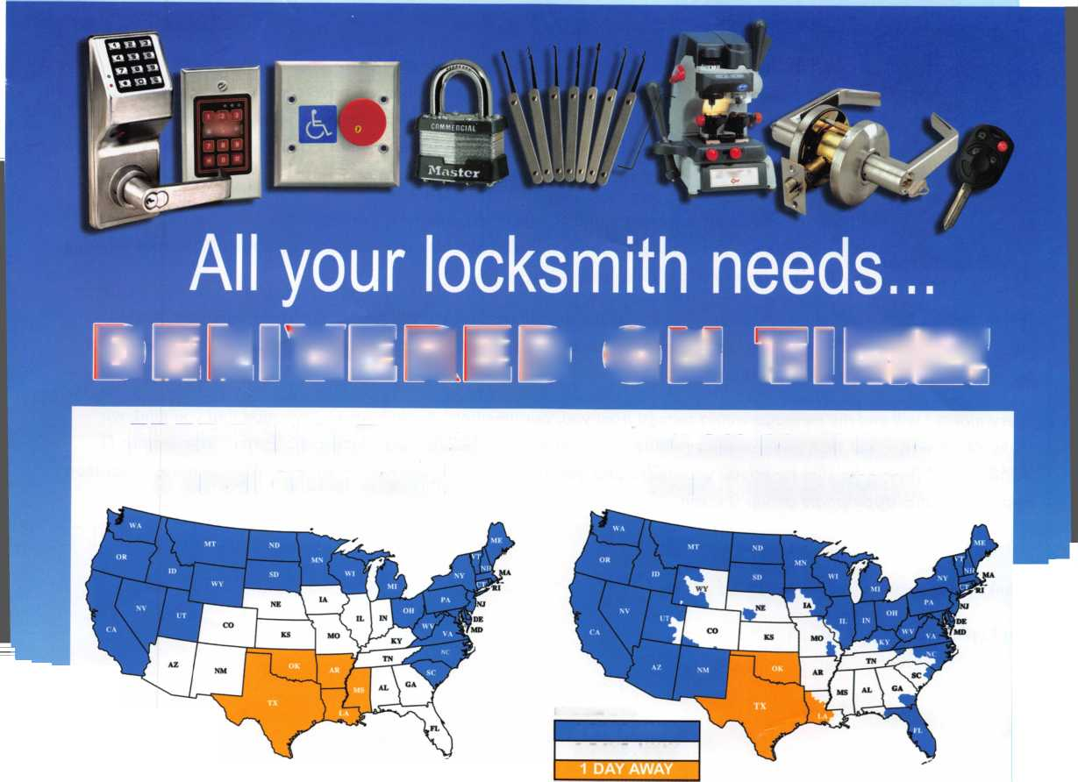

presidential  
v i e w p o i n t

Dear Members,

While I was campaigning for the Presidency, people would ask what my plans were for the  
organization. My answer was to continue in the direction we have been following for the last  
four years. This is not a direction determined solely by the President but by your elected Board  
and by you the members. We need to continue to work together to improve ALOA and make it  
an organization that can grow and evolve with our changing industry.

Thank you to those members and non-members who have contacted me with your comments and  
suggestions. Your input is sincerely appreciated. Let's work together to make ALOA what we want  
it to be, now and for the future.

This month our Board will meet in conjunction with the ILA (Institutional Locksmiths Association) convention in Chicago.

With well over 100,000 institutional locksmiths in this country, we need to strengthen our relationship with this section of  
our industry. Hope to see some of you there.

Every month I will end my message with a request from you, our members. If you have a suggestion that you think will  
make ALOA better and stronger, please email them to me at [president@aloa.org](mailto:president@aloa.org) or mail to PO Box 17944 Tampa, FL  
33682-7944. Please be sure to include your name and member number, if you have one. I will consider every suggestion  
and see to it that appropriate action is taken.

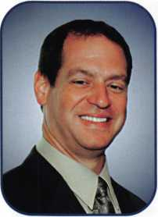

Thanks for you confidence in me to lead ALOA,

Ken Kupferman,

CML, CPS

Keynotes • October 2007

■K*.

**WE ARE LISTENING TO YOUR NEEDS!**

fejALOAl^

**GET READY. CHANGE IS  
AROUND THE CORNER!**

Take a LOOK at some of the new things ALOA has planned for YOU in 2007.

ALOA is excited about the new changes in-store for everyone in 2007. For this membership cam­paign we have listened to the membership and are rapidly making changes to suit your needs.

• Don’t miss out as we roll out our new & improved Keynotes magazine introducing such interactive features as a Q&A section exclusively for members.

• More user-friendly ALOA website.

• More training & education opportunities.

• Better and broader networking possibilities.

ALOA store with more books plus NEW products that help YOUR bottom line.

.

ALOA offers you the strength of over 8,000 leading  
firms & individuals. ALOA is YOUR voice in the  
industry. ALOA represents the collective interests  
of the association to the press, government, and the  
public. ALOA is able to open many doors needed for  
your success in our ever-changing industry.

CONTACT:

Associated Locksmiths of America  
3500 Easy Street  
Dallas, TX 75247

Phone 800-532-2562 • Fax 214-819-9736  
[www.aloa.org](http://www.aloa.org)

*

4BI

^ j



**features**

NEW PRODUCTS!

10

Industry Innovations

Smart new products from industry leaders.

**14**

Exhibitor Spotlight

Welcome to our new monthly feature that will hightlight a current ALOA Convention & Security Expo exhibitor.

**18**

Member Spotlight

Read what Jeff Owens, the president of the South Car­olina Locksmith Association, has to say in this month s member spotlight.

**22**

A Look Inside the SmartKey

Greg Perry takes a look inside the new Kwikset SmartKey to see how it operates and what to do if disassembled.

by Greg Perry, CML, CPS

**28**

Wild Goose (RELOCK) Chase

What will save YOU from a wild relock goose chase?

by Greg Perry, CML, CPS

|  |  |  |
| --- | --- | --- |
|  |  |  |
| AD INDEX |  |  |
| Allstate | Inside Front Cover |  |
| H.L. Flake | 1 |  |
| ALOA Membership | 3 |  |
| ALOA Ring of a King | 7 |  |
| ALOA Bookstore | 13 |  |
| Bianchi | 15 |  |
| ALOA 2008 | 17 |  |
| Fax on Demand | 23 |  |
| ALOA Website | 25 |  |
| Ultra Lift | 26 |  |
| North Bennet Street School ... | 29 |  |
| Letrotruck | 33 |  |
| A&B | 40 |  |
| Turn TO | 40 |  |
| ClearStar | 40 |  |
| Chase Paymentech Solutions. | 40 |  |
| PBP | 40 |  |
| Safetech 2008 | 41 |  |
| Jet Hardware | Inside Back Cover |  |
| CCL | Back Cover |  |
| L |  |  |

**30**

NEW Membership Department!

Check out our brand new department dedicated strictly to member related issues.

by Ellen McEwen, Membership Developement Manager

**44**

Annual Meeting Minutes Draft

by John Soderland

**Departments**

|  |  |  |  |  |  |  |  |  |  |  |
| --- | --- | --- | --- | --- | --- | --- | --- | --- | --- | --- |
| Presidential |  | Execut | ve | 5 | Calendar | 8 | Membership . | ...32 | Associate |  |
| Viewpoint | 2 | Applic | 3nts .... | 6 | Core | 9 | Classified | ...34 | Members | 36 |
|  |  |  |  |  |  |  |  |  | Legislative ... | 38 |

Visit our NEW website at

[www.aloa.org](http://www.aloa.org)

**executive**



Volume 53, Issue 9

Additional contact information for the ALOA Board is available on the ALOA website—  
[www.aloa.org](http://www.aloa.org) or by contacting the ALOA office at 3500 Easy Street; Dallas, TX 75247;  
(800)532-2562; FAX (214)819-9736; e-mail [aloa@aloa.org](mailto:aloa@aloa.org).

Editor & Director of Creative Services

Betty Southerland [betty@aloa.org](mailto:betty@aloa.org)

Advertising Sales

Kim Hammond voice: 817-645-6778

Fax: 817-645-7599 e-mail: [adsales@aloa.org](mailto:adsales@aloa.org)

Executive Director

Charles W. Gibson, Jr., CAE [charlie@aloa.org](mailto:charlie@aloa.org)

Associate Executive Director

David Lowell, CML, CMST [david@aloa.org](mailto:david@aloa.org)

Convention & Meetings Manager

Jo Anne Mims [joanne@aloa.org](mailto:joanne@aloa.org)

Operations/Membership Manager

Mary May [mary@aloa.org](mailto:mary@aloa.org)

Director of IT Operations

Greg K. Jackson [greg@aloa.org](mailto:greg@aloa.org)

Comptroller

Kathy Romo [kathy@aloa.org](mailto:kathy@aloa.org)

Membership Development Manager

Ellen R. McEwen [ellen@aloa.org](mailto:ellen@aloa.org)

Convention & Meetings Assistant Karen Lyons  
Mail Room Coordinator Kevin Wesley

Graphic Designer Margarita Garza

Accounting Coordinator Joyce Nixon

Assistant Education Manager Bob Stafford, CML  
Legislative Manager Tim McMullen, JD, CAE

Contributors

Jerome Andrews, CML  
Paul Chandler, CRL  
Claire Cohen, CML  
Brian Costley, CML, CMST  
Eric Costley, CRL

Ray D'Adamo, CML Billy Edwards, CML Dan Graffeo, CRL,CMST Jim Hancock, CPL Jeff Nunberg, CML, CMST

Randy Simpson, CML, CPP Robert Stafford, CML Dave Thielen, CML Greg Perry, CML,CPS

Tom Seroogy

Charles Stephenson, CPS

Dennis Watanabe, CML, CMST

Mission Statement: The Associated Locksmiths of America, Inc. is dedicated to enhancing the professionalism, education and ethics among  
locksmiths and those in related sectors of the physical security industry. With approximately 8,000 members in the United States, Canada and the free-  
world, ALOA is poised to help members obtain the knowledge, the strength, and the confidence to perform their role in the physical security field with  
pride and dignity. But it is only through active involvement and participation that ALOA can fully achieve its potential—and can help members to achieve  
theirs.

Policies: Keynotes® is the official publication of the Associated Locksmiths of America, Inc. (ALOA). Keynotes® acts as a moderator without approving,  
disapproving, or guaranteeing the validity or accuracy of any data, claim, or opinion appearing under a byline or obtained or quoted from an ac-  
knowledged source. The opinions expressed by the authors do not necessarily reflect the official views of ALOA. Also, appearance of advertisements and  
new products or service information does not constitute an endorsement of products or services featured by the Association. The Association does not ac-  
cept responsibility for the inaccuracy of any data, claim, or opinion appearing in this publication, due to typographical errors on the part of the authors,  
Association staff or its agents.

Editor's Note: This publication is designed to provide accurate and authoritative information in regard to the subject matter covered. It is provided and  
disseminated with the understanding that the publisher is not engaged in rendering legal or other professional services. If legal advice and other expert  
assistance is required, the services of a competent professional should be sought.

Authors' Payment: Payment for eligible submissions to Keynotes will be based on the following criteria: topic, time spent and past contributions. Authors who  
regularly submit to Keynotes® are generally paid a higher rate. The latter is especially true of authors who write to fit specific editorial needs and submit said copy  
by Keynotes® deadlines. As a general guideline: Average payment for a 750 word, business or 'light' technical article would be $200. Payment for a 1500 word  
article involving significantly higher time and research efforts would be $400.

Payment will not be offered for articles submitted by ALOA employees or members of the ALOA Board of Directors (unless material is of a technical na-  
ture), nor for articles submitted by a company that promote that company's products or services. ALOA reserves the right not to pay for articles submitted  
by an individual(s) that promote a particular company's products or services.

Disclaimer: The Associated Locksmiths of America, Inc., (ALOA), reserves the right to refuse any article for any reason. Additionally, ALOA reserves  
the right to edit, amend or modify any article submitted for publication in order to preserve technical accuracy, clarity, fairness or grammatical correct-  
ness. ALOA will make the best efforts to notify the author of any changes. The extent of ALOA's liability for any article or information contained therein  
will be a notice of correction or retraction in the next possible issue.

Keynotes® (ISSN 0277 0792) is published monthly except for the combined June/July issue by The Associated Locksmiths of America, Inc.,  
3500 Easy St., Dallas, TX 75247-6416. Telephone: (214) 819-9733; FAX (214) 819-9736; e-mail [aloa@aloa.org](mailto:aloa@aloa.org). Subscription rates for  
members—$15.00 per year. Periodical class postage paid at Dallas, Texas. POSTMASTER: Send address changes to: Keynotes, 3500 Easy St., Dallas,  
TX 75247-6416. © Copyright 2003, All rights reserved. No part of the contents may be reproduced or reprinted in any form without prior  
written permission of the publisher.

President

Ken Kupferman, CML, CPS  
(813) 232-7600  
[president@aloa.org](mailto:president@aloa.org)

Secretary

John Soderland, CML, CMST  
(414) 327-5625  
[secretary@aloa.org](mailto:secretary@aloa.org)

Directors, Northeast

Tom Foxwell  
(410) 206-5772  
ned i rector@aloa. org

Robert D. DeWeese, CML, CPS  
(410) 285-0101  
ned i rector@a loa. org

Directors, Southeast

Tom Gillingham, Jr., CML, CPS  
(615) 300-3777  
[sedirector@aloa.org](mailto:sedirector@aloa.org)

Steve Myslik, CRL  
(843) 321-9200  
sedirector@aloa .org

Director, North Central

William Smith, RL  
(920) 893-5282

Guy Spinello, RL  
(815) 394-1000  
ned i rector@a loa. org

Director, South Central

CD Lipscomb, CML, CPS  
(903) 874-3522  
sed i rector@a loa. org

Directors, Southwest

Greg Parks, CRL  
(858) 271-1155  
swdirector@aloa .org

Gordon Racine, CML  
(719) 384-4707  
swd i rector@aloa. org

Director, Northwest

Keith E. Whiting, CML, CFL  
(360) 601-5656  
nwdirector@aloa .org

Director, International

Hans Mejlshede, CML  
(453) 539-3939  
[eurdirector@aloa.org](mailto:eurdirector@aloa.org)

Director, Associate

Dan Floeck  
(800) 231-4105  
[asdirector@aloa.org](mailto:asdirector@aloa.org)

Trustees

[trustees@aloa.org](mailto:trustees@aloa.org)

Robert E. Mock  
(856) 863-0710

Randy Simpson, CML, CPP  
(281) 240-5959

William Young, CML, CPS  
(610) 647-5042

Past Presidents

2005-2007 Robert E. Mock  
2003-2005 William Young, CML, CPS  
2001-2003 Randy Simpson, CML  
1999-2001 John Greenan, CML, CPS  
1997-1999 Dallas C. Brooks  
1995-1997 David Lowell, CML, CMST  
1993-1995 Breck Camp, CML  
1991-1993 Henry Printz, CML  
1989-1991 Evelyn Wersonick, CML, CPS  
1987-1989 Leonard Passarello, CPL  
1985-1987 Joe Jackman, CML  
1983-1985 Stanley Haney, CPL  
1981-1983 Louis LaGreco, CPL  
1979-1981 John Kerr, RL  
1977-1979 Clifford Cox, CML  
1974-1977 Charles Hetherington  
1972-1974 Gene Laughridge  
1970-1972 William Dutcher, RL  
1968-1970 Constant Maffey, RL  
1966-1968 Harold Edelstein, RL  
1964-1966 William Meacham  
1962-1964 Robert Rackliffe, CPL  
1960-1962 Edwin Toepfer, RL  
1956-1960 Ernest Johannesen



Keynotes • October 2007

CA

LA

applicants

for membership



**t**

Alameda

Patrick Hather

Santee

Jeffrey A. Pugh

Sponsor: Gregory A. Porks CRL

CO

Fort Collins

Matthew Myers

DC

Washington

Darren Edwards

FL

Leesburg

Raymond M. Peidl Mary Esther Shawn Anderson

Tampa

Robert W. Curry

Sponsor: Ken Kupfermon CML, CPS

GU

Tamuning

John D. Estes

Sponsor: Andrew Estes

IA

Middletown

Wayne Johnson

Antioch

Joseph Parrilli

Madisonville

Darren Harrison

MA

Malden

Robert Puopolo

Randolph

Sandy Joe Peluso

MD

Damascus

Matthew T. Lozupone

Upper Marlboro

Robert E. Graham

Ml

Detroit

Kelvin L Heath

Sponsor: Dwayne S. Crenshaw CML

NJ

Mays Landing

Michael Carter

NY

New York

Kevin Hall

SC

Georgetown

Rhoda K. McClain

Sponsor: Jeffrey Owens

TN

Nashville

Anthony L. Locklayer

TX

Fort Worth

Debbie D. Gibbs

Sponsor: Clifford D. Lipscomb CML, CPS

Killeen

Scott Barth Springtown

Pamela J. Street

Sponsor: Clifford D. Lipscomb CML, CPS

Cheston G. Carlisle

Sponsor: Clifford D. Lipscomb CML, CPS

UT

Layton

Jeffery W. Backus

Sponsor: Julie A. Vaughan

WA

Medical Lake

David Kydd

Wl

Chippewa Falls

Verdun C. Dvorak

ON

Milton

Eddie Sturge

Sponsor: Thomas Fraser

Great Britain

Bedford

Ian Impey

These applicants are scheduled for clearance as members of ALOA. The names are published for member review and comment within 30 days of this Keynotes issue date, respectively, to ensure appli­cants meet standards of ALOA's Code of Ethics. Protests, if any, should be addressed to the Membership Department and must be signed. Active Membership applicants (a) have worked in the industry two or more years. Allied Membership (AL) applicants are not locksmiths, but work in a security-related field. Apprentice Membership (AP) applicants have worked in the industry less than two years.

Keynotes • October 2007



**RING of a KING**

|  |  |  |  |
| --- | --- | --- | --- |
| Member Name Sponsorships | | Peter R. Hall | ....17 |
|  |  | Eugene R. Altobella Jr | ...17 |
| Kwok-kei Leung | ...223 | Joseph P. Ferrero CML | ...16 |
| Toshihiro Asano | ...119 | Kenneth E. Kim CRL, CPS | ,...16 |
| Henry W. Raymond | ....92 | John A. Ilk CRL, CPS | ...16 |
| Yuriko Yanai | ....82 | Evelyn V. Wersonick CML, CPS ... | ...15 |
| David M. Troiano | ....69 | John W. Soderland CML, CMST... | ...15 |
| Clifford D. Lipscomb CML, CPS .. | ....67 | Michael E. Jordan Jr, CML | ...15 |
|  | ....66 | lohn 1. Greenan CML CPS | 15 |
| William Lee CRL | ....66 | Brian J. Reetz | ...15 |
| Michael B. Groves | ....58 | Richard C. Sievers | ...15 |
| Jack Hobin CPL | ....51 | Charles E. Batcke CPL, CPS | ...15 |
| William B. Neff CML CPP PSP .... | ....48 | Steve L. Cothron | ...15 |
| Jim Williams CRL | ....45 | Leonard J. Passarello CPL | ...14 |
| C Allan Halverson | ....40 | Robert E. Mock | ...14 |
| Myeong-Rae Cho | ....38 | Gary F. Teams CPL | ...14 |
| David M. Lowell CML, CMST .... | ....37 | Todd K. Ladwig CML, CPS | ...14 |
| Dana L. Barnum CML | ....35 | John D. Cannon CML | ...14 |
| Barry K. Leas CRL | ....35 | Timothy J. Moore CRL | ...14 |
| Hans Mejlshede CML | ....34 | Gregory L. Perry CML, CPS | ...14 |
| Scott L. Henke CPL, CPS | ....34 | Paul M. Souber | ...14 |
| Robert D. DeWeese CML, CPS.... | ....34 | James T. Brickler CML | ...14 |
| Danny W. Rudd CPL | ....33 | Joseph C. Fuller CML, CMST | ...13 |
| Peter Sarailian CRL | ....33 | Robert C. Rodocker CPL | ...13 |
| William L. Young CML, CPS | ....33 | Calvin G. Harris CML | ...13 |
| William T. Beranek | ....32 | Barry L. McMenimon CPL | ...13 |
| James L. Hancock CPL | ....32 | Rolando Bouza | ...13 |
| Larry A. Warnick CML | ....31 | Basil W. Shannon CPL | ...12 |
| Robert W. Duman Sr, CML | ....31 | Douglas S. Wilson CPL | ...12 |
| Eugene R. Altobella Sr | ....31 | William J. Wickward CML | ...12 |
| John C. Elliott Jr, CML, CPS | ....30 | Bruce J. Tarbet CML, CPS | ...12 |
| Dallas C. Brooks | ....28 | Gordon R. Racine CML | ...12 |
| Philip A. Rovenolt CPL | ....28 | Robert M. Massard CRL,AHC | ...12 |
| Breck H. Camp CML | ....27 | Thomas Demont CML, AHC | ...11 |
| Lawrence F. Smith Jr, CML | ....27 | J Casey Camper CML, CPS | ...11 |
| Marian M. Swann CRL | ....27 | Bruce P. Eagan CML | ...11 |
| James M. Watt CML, CPS | ....27 | Kevin R. Wilson CML, CPS | ...11 |
| John L. Shandy CML | ....26 | Dana L. Lee CML | ...11 |
| Jeffrey S. Nunberg CML, CMST .. | ....26 | Andrew A. Edmunds CML, CPS ... | ...11 |
| J Thomas Hood CML | ....26 | Maurice R. Horne CML | ...11 |
| Elvis D. Hammerschmidt CPL | ....25 | Daniel S. Enriquez CRL | ...11 |
| Robert H. Stafford, CML | ....25 | Dale L. Knowles | ...11 |
| Anthony J. Ramunno CML, CPS .. | ....24 | Charles E. Haas CML | ...10 |
| Takashi Kuwana, CRL | ....24 | Lester S. Brodsky | ...10 |
| Man-Soo Seo RL | ....23 | Ralph O. Warren CML | ...10 |
| Jerome L. Cohen CML | ....22 | Thomas R. Smith CPL | ...10 |
| Peter K. Gauthier CPL, CPS | ....22 | Timothy K. Chow | ...10 |
| John S. Dorsey CML, CPS | ....20 | Richard T. Johnson CPL | ...10 |
| James J. Cawby CML, CPS | ....20 | Raymond C. Lusk CML | ...10 |
| William P. Grant CRL | ....20 | Vincent L. Formon CML, CPS | ...10 |
| Walter W. Lascar Sr., RL | ....19 | Carroll T. Croson Jr | ...10 |
| Thomas G. Vandersteen CML, CPS.. 19 | | David M. Howdle | ...10 |
| Ernest W. Wright | ....18 | Jim L. Jeffries CPS | ...10 |
| James E. Gruber CPL | ....18 | Andrew S. Dennison CPL, CPS | ...10 |
| William J. McElheney CML | ....18 | Gene Eldridge CPL | ...10 |
| Ronald E. Heidzig | ....18 | Larry L. Votaw CML | ...10 |
| Joe J. Lee CRL | ....18 |  |  |



How can I join the President's Club?

You can earn a membership in this prestigious club by recruiting  
just 10 new members for ALOA.

*Any ALOA member may participate.

What do I get?

When you recruit 10 members, you receive a  
handsome blue blazer with a President's Club crest.  
For each additional five members you recruit, you re-  
ceive a lapel pin with gold-filled numbers, indicating,  
your recruiting successes.

You also get the satisifaction of knowing that you are  
helping your association, helping your industry grow,  
and you are helping fellow locksmiths achieve success.

How do I get started?

Mail the form below to the ALOA office for a supply of  
applications (800) 532-ALOA or FAX (214) 819-9736.  
One President's Club credit is awarded for each new ap-  
plicant. Credit is awarded only after the membership ap-  
plication is pproved. However, the credit will apply for  
the period in which the application is received. Failure to  
identify yourself as the sponsor on the application form  
at the time it is submitted to ALOA for processing will  
forfeit any credit.

Yes! I want to join the ALOA President's Club.

Please rush me applications so I can start earning credit toward membership in the club!

Company

Address

City

Zip

Mail this form to ALOA • 3500 Easy St. • Dallas, Texas 75247-6416

upcoming events

10/9-12 Pacific Security Conference 10/9-12 Portland, OR Airport Holiday Inn &

Conference Center pacificsecurityconference.com

Institutional Locksmiths Association Industry Tradeshow Willowbrook, IL Holiday Inn [www.ilanational.org](http://www.ilanational.org)

10/10-13 SERLAC Industry Tradeshow Orlando, FL Holiday Inn Resort, International Drive [www.serlac.com](http://www.serlac.com)

10/13-20 DHI 32nd Annual Conference & Expo Nashville, TN Gaylord Opryland Hotel [www.dhi.org/annual](http://www.dhi.org/annual)

10/20 VLA Meeting & Class • Charlottesville, VA Contact: Elliot Paul Conner [va_locksmith@verizon.net](mailto:va_locksmith@verizon.net)

10/23-26 IFMA Industry Tradeshow New Orleans, LA New Orleans Convention Center [www.ifma.org](http://www.ifma.org)

10/25-28 GPLA Industry Tradeshow  
Cherry Hill, NJ

Clarion Hotel & Conference Center [www.gpla.org](http://www.gpla.org)

11/7-11

Clark Security Products Security Expo Baltimore, MD Marriott BWI [www.clarksecurity.com](http://www.clarksecurity.com)



2/6-9 TLA Convention Austin, TX

Radisson Hotel Austin North 6000 Middle Fiskville Road

Resv: (888) 201-1718  
Tel: (512) 451 -5757  
Fax: (512) 467 - 7644

**UPCOMING ACE CLASSES UPCOMING PRP Sittings**

|  |  |  |  |
| --- | --- | --- | --- |
| October 8-13, 2007 | Appleton, Wl • Fox Valley Technical College [www.ftvc.edu/security-crimeprevention](http://www.ftvc.edu/security-crimeprevention)  6-Day Basic Locksmithing Course | 10/5/07 | Friday 8:00am • Dallas, TX • ALOA Certification  ALOA Training Center • [education@aloa.org](mailto:education@aloa.org)  800-532-2562x104 |
|  | Jerry Antoon • 800-735-3882x2482 • [antoon@fvtc.edu](mailto:antoon@fvtc.edu) | 10/7/07 | Sunday 8:00am • Syracuse, NY • Ron Smith, CPL, CJIL |
| October 9-12, 2007 | Portland, OR • Pacific Security Conference • [www.pla-pro.org](http://www.pla-pro.org)  For a complete listing contact: Keith Whiting |  | Central New York Locksmiths Assn. • [advsl@imcnet.net](mailto:advsl@imcnet.net) 315-782-0912 |
|  | 360-601-5656 • [kwinwa@yahoo.com](mailto:kwinwa@yahoo.com) | 10/12/07 | Friday 6:00pm • Portland, OR • Jim French |
| October 12 & 13, 2007 | Kansas City, MO • Missouri-Kansas Locksmith Association Advanced Automotive Lock Service |  | Pacific Security Conference • [frencje@yahoo.com](mailto:frencje@yahoo.com)  503-235-4000 |
|  | Transponders the Complete Story  Bob Turner • 816-525-5522 | 10/14/07 | Sunday 8:00am • Orlando, FL • James Barnhardt, RL  SERLAC • [questions07@serlac.com](mailto:questions07@serlac.com) • 800-845-5294 |
| October 20, 2007 | Omaha, NE • Nebraska Chapter of ALOA  Keyless Mechanical Lock Service w/L-20 PRP  Elmer Howard • 402-676-8973 • [safeman@cox.net](mailto:safeman@cox.net) | 10/20/07 | Saturday 6:00pm • Charlottesville, VA • Elliot Paul Conner, CML Virginia Locksmiths Assc. • 703-440-8326 va _locksmith@verizon. net |
| November 3 & 4, 2007 | Connecticut • Nutmeg Locksmith Trade Association  Defense Against Methods of Entry | 10/28/07 | Sunday 8:00am • Cherry Hill, NJ • Robert Shuetrumpf, CRL, CJIL Greater Philadelphia Locksmiths Assc. • 856-486-9280 |
| November 7, 2007 | Safe Lock Servicing for Locksmiths  Bill Brooks, RL • 203-269-7643 | 11/2/07 | Friday 8:00am • Dallas, TX • ALOA Certification  ALOA Training Center • [education@aloa.org](mailto:education@aloa.org) |
| Baltimore, MD • Clark Security Products |  | 800-532-2562x104 |
| November 9-10, 2007 | Safe Lock Servicing, Transponder Servicing  Joan Emrick • 858-974-6737 [www.clarksecurity.com/Events.aspx?event=Easternre](http://www.clarksecurity.com/Events.aspx?event=Easternre)  Dallas, TX • ALOA Training Center • [www.aloa.org](http://www.aloa.org)  Intermediate & Advanced Master Keying  ALOA Education • 800-532-2562x104 • [education@aloa.org](mailto:education@aloa.org)  Ft. Wayne, IN • Northern Indiana Chapter of ALOA | 11/11/07 | Sunday 8:00am • Baltimore, MD • Joan Emrick  Clark Security Products • [joan.emrick@clarksecurity.com](mailto:joan.emrick@clarksecurity.com) 858-974-6737 |
| November 16-18, 2007 | 11/16/07 | Friday 3:30pm • Fort Wayne, IN • Jeremy Rodocker, CML, CPS Northern Indiana Chapter of ALOA • [rodockers@hotmail.com](mailto:rodockers@hotmail.com) 260-459-1500 |
| PRP Exam, Domestic Auto w/L-03 PRP, Foreign Auto w/L-04 PRP Jeremy Rodocker, CML, CPS • 260-459-1500 [rodockers@hotmail.com](mailto:rodockers@hotmail.com) | 12/8/07 | Saturday 1:00pm • Dallas, TX • ALOA Certification  ALOA Training Center • [education@aloa.org](mailto:education@aloa.org)  800-532-2562x104 |
| December 3-8, 2007 | Dallas, TX • ALOA Training Center • [www.aloa.org](http://www.aloa.org)  ALOA Education • 800-532-2562x104 • [education@aloa.org](mailto:education@aloa.org) | 12/9/07 | Sunday 1:00pm • Muskego, Wl • John Soderland, CML, CMST [prolock@aol.com](mailto:prolock@aol.com) • 414-327-5625 |

**Contact the ALOA Education De­partment for a list of classes and training offered in-house.**

**? core**

Bratfest

ALOA Board  
Secretary John  
Soderland (left),  
and North Central  
Director Bill Smith  
(right) attended the  
annual IDN H.  
Hoffman Bratfest  
and trade show in  
Milwaukee Wl in  
August. John and  
Bill are pictured

with representatives from Alarm lock, Multi-lock, the Institutional Locksmiths Association, and HPC, Inc.

A good time was had by all, and nobody left the event hungry.

Condolences

To member Mike Cutler, CML on the passing of his dear father.

ALOA Receives Continued Media Coverage Re­garding Phony Locksmiths

View the story online at:

<http://abclocal.go.com/kabc/story?section=consumer&id=5667726>

In Memory

Phillip W. Halderman 66 of North Miami, Florida passed away Saturday September 1st at his residence. He was born in Worthington, Indiana April 3rd, 1941 to Joseph Roscoe and Virginia (O'Neal) Halderman. He was a self employed master locksmith for more than 20 years and a member of the American Locksmith Association.

Halderman is survived by his step mother Ruth (Bobbi) Booher of Spencer, two sons Terry Halderman of Boggstown, Indiana, and Mark Halderman of Covington, Kentucky, one stepdaughter Teresa Fusco of San Jose, California, one step grandchild, and one brother Joseph R Halderman of Indianapolis, Indiana.

He was preceded in death by one brother and one sister.

Rev. Paul D. Shear oficiated at a Memorial Service was held at the West & Parrish & Pedigo Funeral Home in Spencer, Indiana on Saturday September 29, 2007.

Online condolences may be made to the family at [www.westparrishpedigo.com](http://www.westparrishpedigo.com).

Napco Introduces Freedom To Choose...Freedom 64 Coded & Freedom 64 Code-Free

NAPCO Security Systems, Inc., is proud to introduce a second technologically ad­vanced Freedom™ touchpad to choose from. Napco is introducing new Freedom- Coded for conventional installs, a user-friendly unit that cuts false alarms.

Now with Freedom, you have a choice of two talking touchpads with one 64-zone panel to standardize on. Choose Freedom Coded for a traditional burglar alarm unit which installs with up to 64, 3 to 6 digit user codes, or Code-Free Freedom hybrid for a high technology security system that eliminates false alarms and maximizes account retention.

Both multifunction touchpads feature a built in smart burg/fire siren. This powerful UL dual tone siren saves on labor, time and equipment costs. Each unit has a built in adaptive occupancy Pet PIR with 25' wide-angle coverage, an adjustable volume

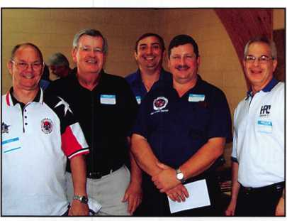

voice prompt assist speaker and a 4 zone EZM expander.

Freedom 64 Code-free and Freedom 64 Coded Security Systems work with the F-64 Panel, which features 8-64 partitionable zones and reliable Gemini Wireless support. To learn more about Freedom 64 Coded & Freedom 64 Code-Free, please visit [www.napcosecurity.com](http://www.napcosecurity.com).

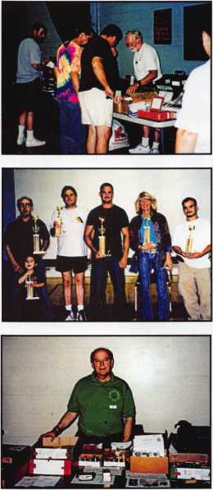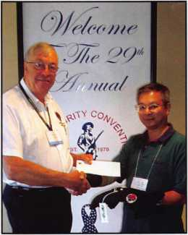

Thirteenth Annual  
Locksmith Flea Market

The Master Locksmith Association  
of New Jersey presented it's 13th  
Annual Flea Market on June 10,  
2007. There were approximately  
40 booths at the show.

Participants were able to buy, sell  
and trade items such as new and  
used locks. There was also a  
manipulation contest and lockpick-  
ing completion activities.  
Photographs by the Official ALOA  
Member Photographer, Mr. Walter  
Lascar.

The Master Locksmith  
Association of  
New Jersey Elects  
New Officers

New officers include:

President, Charles Green, CRL  
Vice President, Bill Fury  
Secretary, Judy Fury  
Treasurer, Patti Canro, CPL  
Sargent at Arms, Joe LaVigne, CRL  
Chaplain, Dave Ackerson

Yankee Winner

Kenneth Jong with J&J Locksmiths won a  
door Prize for an ALOA Convention and  
Security Expo package worth $700.00 at  
the recent Yankee Security Show.



PRODUCTS

FROM

INDUSTRY

LEADERS

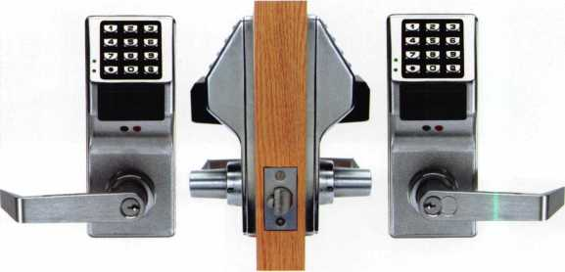

Alarm Lock Unveils the PDL5300 to The Trilogy Family of Products

Alarm Lock Systems, Inc., a well-established leader in se­curity and locking technologies will be introducing the PDL5300. It is the newest addition to the Trilogy family and features a double-sided keypad with PIN-code and HID reader access on both sides of the door. PDL5300’s inge­nuity grants direction-specific access for up to 2000 users. Easily programmed and time-date stamped, Alarm Lock’s PDL5300 provides 40,000 event audit trail also indicating the direction of door usage. Moreover, the data port for programming and querying audit trail is on the primary side of the door, along with a functioning mechanical key over­ride. Similar to PDL3000 but with PIN keypad and prox reader on both sides of the door, PDL 5300 is an easy in­dependent way of controlling directional access through the door via code and/or card. Each user can be pro­grammed for access to go into or out of specified or all areas one or both ways.

Digital Locker and Cabinet Locks

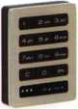

From Assured Lock and Supply, day-use clien-  
tele are now able to lock and unlock any avail-  
able locker with their own four-digit code of  
choice, eliminating the need to wait in line for a  
key to be issued or remembering to bring their  
own lock. Simply close the door enter your  
own 4 digit code, the unit will lock and stay  
locked until the code is re-entered.

These locks are perfect for the Health and Fitness Facili­ties, Day Spas, Golf Courses, Country clubs or anywhere with temporary storage needs

These units are available in a verity of different sizes for door thickness.

LABLED - LED Ear  
Light

Introducing a new product from  
LAB that is great for picking and  
wafer reading in low-light areas

or in a van when repinning cylinders. LED high in-  
tensity focused beam adjustable in the vertical and  
horizontal. Two replaceable CR-2016 lithium batter-  
ies included. Comfort padded universal fit around  
the ear.



J

**ALARMED EMERGENC/ EXIT**

Alarm Lock’s 700x28WP & 250x28WP Is Now Weatherproof

Alarm Lock Systems, Inc., has released its weather­proof electronic alarmed panic locks models 700x28 & 250x28. A well-established leader in security and locking technologies, Alarm Lock has taken great

strides to improve the Sirenlock panic exit alarms. Technologically enhanced and more durable than prior models, 700x28 & 250x28 panic locks now serve well for outdoor and indoor use. These weather-proof locks are great for exposure to precip­itation and harsh weather conditions. Operating tem­peratures range from -20° F to +140°F or (-29° C to +60°C.) Deadbolt and deadlatch meet relatching re­quirements and a blaring 99db dual tone siren can certainly scare off any intruder.

Special features on both models now include a changeable 2-minute alarm cutoff or manual reset. Powered with a long-life sealed 9VDC alkaline bat­tery pack, there is no need to constantly be chang­ing dead batteries. Typically, these batteries will last one year on standby. Both 700x28 & 250x28 weath­erproof electronic alarmed panic locks meet or ex­ceed UL, CFM, ADA, and NYC housing requirements. These alarmed emergency exit panic locks are handicap accessible, non-handled and easily installs on single or double door surfaces. An audible low warning system allows users to immedi­ately determine if battery replacements are needed. In addition, each unit comes with an exterior key control, door warning sign and a single lock bolt 1” throw made of heavy die cast zinc alloy and rein­forced steel inserts.

Certain aspects vary between these two models. In

terms of dimensions, 250x28WP measures 18”  
width, 8 1/2” height and 3 1/4” depth. If you add an  
extended clapper plate, the width changes to 24  
inches across. 700x28WP on the other hand, meas-  
ures almost double in width or 33” wide, with a height  
of 8 1/2” and a depth of 3 1/4”. If you intend to use a  
glass door, a 48” extruded aluminum channel with  
push bar is available for 700x28WP. Both 33” and 48”  
700WP models are MEA approved. Die-cast cover  
finishes differ between each model. 700WP is avail-  
able in 312 duro, red, duronodic or aluminum and  
model 250WP is available in aluminum finishes only.

When mounting, be certain that the center of each  
unit measures approximately 38 inches from the  
floor for optimal use.

Smart Wedge Universal  
Rekeying Kits by LAB

LSW003:

* .003 Increments
* 92 Sizes
* Top Pins: .024T - .200T, .235T
* Spool Pins .160J .165J .180J
* T-Pin .170TP
* Bottom Pins: .159B -  
  .354B (Contains the  
  most commonly used  
  sizes - No Dead  
  Stock.)

LSW005

* .005 Increments
* 86 Sizes
* Top Pins: .010T -  
  .200T .230T .235T
* Spool Pins .160J  
  .165J .180J
* T-Pin .170TP
* Bottom Pins: .155B -  
  .360B

Features

* 40% Smaller in width  
  than

Pro Kits 13-1/4" x 10-  
1/2"

* Developed by locksmiths with  
  confined workspaces in mind.
* Color Passport Pin Chart®
* Pin sizes printed the same color as the Pins
* Easy-to-use time saver
* Slide-out tool drawer
* 3 deep spring pockets
* NEW tangle-resistant .115 long springs & .115 short springs
* NEW T-Pin spring for Schlage “F” Series Cylinders
* Double-sized pin pockets hold up to 200 pins per size
* Large tool pocket on top of tray
* Injection-molded high-impact tray with pin sizes printed  
  100% Larger
* Contains 3 sizes of spool pins and the “F” Series T-Pin for  
  Schlage Cylinders.
* 72 pins per pocket, 100 springs per pocket

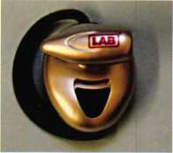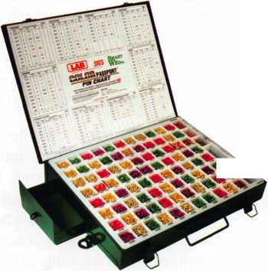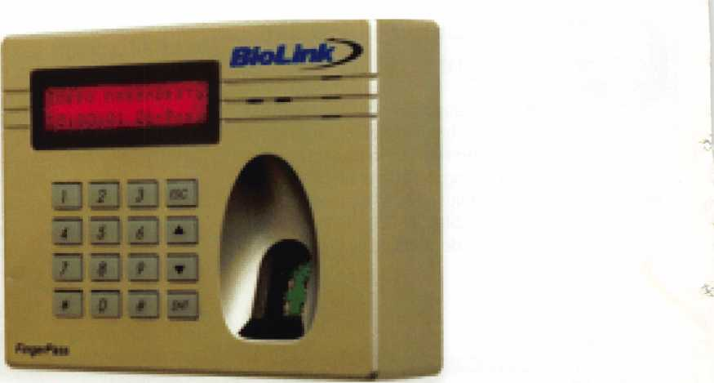

Biolink Fingerpass

BioLink announces the release and mass produc­tion of BioLink FingerPass 1C, a biometric terminal. It allows controlling physical access and recording the employees’ work hours by identifying them with fingerprints, contactless cards and/or PIN-code (used separately or in combination). Upon success­ful identification, the terminal issues a command to open an electromagnetic door-lock, turnstile or gate, and, simultaneously, registers the employee’s arrival or departure event in the system.

The recommended identifiers to be used with Fin- gerPass 1C are biometric parameters - fingerprints, as they are immune to loss, theft or forgery. They are a good identification tool for regular employees, while one-time visitors can be identified with con­tactless cards. To restrict access to highly secure areas, such as executives’ offices, server rooms or stock rooms, two-factor identification (fingerprint + card) can be implemented.

BioLink FingerPass 1C can operate either sepa­rately or in combination with BioTime, a biometric time tracking and access control system. When used separately, the terminal is managed through its own keypad and display. When combined with BioTime, it is managed through the BioTime soft­ware, which is more convenient and effective.

BioTime allows centralizing access control and time monitoring features within the entire organization or enterprise, including its remote offices. A flexible modular structure allows configuring the system using various modules: users’ biometric information

can be registered either in an HR department or se­curity department. Right upon enrolling the em­ployee’s data into the system, this employee can start making use of the biometric terminal BioLink FingerPass 1C (located, for example, at the en­trance).

The terminal interaction with BioTime can be done in three ways. In an autonomous mode, digitized fingerprint templates are stored in the terminal in­ternal memory; in a network mode, biometric data is stored on the BioTime server (number of users is unlimited); in a combined mode, in the event of temporary server disconnections (due to LAN fail­ures) the terminal continues operating, and upon restoring the connection, it transfers the accumu­lated information about the arrival/departure events to the server. The terminal’s internal memory is able to store up to 8 000 event records.

Apart from the keypad and display, the terminal comprises an optical fingerprint scanner and a reader of contactless Mifare cards. The image reso­lution of a fingerprint scanner is 508 dpi; operation with LAN is done through the Ethernet interface; to connect other types of card readers, RS-232 and Wiegand interfaces are used.

Piotr Pertsov, Director of Business Development in BioLink, says: “Thanks to the stylish design, ease of installation and assembly of FingerPass 1C, the major part of terminals has been sold out at the production phase! The most popular application of FingerPass 1C is with turnstiles, as it supports the majority of turnstile types.”

PRP Resource Guide 25.00

The Complete Book of Locks & Locksmithing ..40.00

Wafer Lock Reading 19.95

Door Lock Encyclopedia 39.95

Lock Repair Manual 14.95

Interchangeable Core Cylinders 34.95

Picking & Impressioning 45.00

The Lure of the Lock 29.95

High Security Safes, vol 1 175.00

High Security Safes, vol 2 175.00

Safeman's Guide, vol 13 9.95

Safe Deposit Depth and Space Manual 99.00

Safe Technician's Reference Manual 155.00

Gun Safes 1 10.00

Modern Safe Opening 59.95

Dave McOmie on Vault Doors, vol 1, Bank Vaults 1 10.00

Dave McOmie on Vault Doors, vol 2, Fire and Plate Vaults 1 10.00

Modern Safe Locks 95.00

Drilling Safes 95.00

Safe Deposit Box Service 39.95

Foreign Car Impressioning Book 29.95

Impressioning Ford and GM Side Bar Locks 29.95

Automotive Lock Servicing Update #1: GM 10-Cut Locks 29.95

Automotive Lock Servicing Update #2: GM 10-Cut Locks 29.95

Automotive Lock Servicing Update #3: GM 8-Cut Locks 29.95

GM Locks: Perfect for the Beginning Locksmith! 29.95

Ford Locks: Pin Tumbler and Ten-Cut Systems 29.95

Chrysler Pin Tumbler Locks 29.95

Chrysler Double-Bitted Locks 29.95

Toyota Split-Tumbler Locks 29.95

Basic Door Panel Servicing 29.95

Advanced Door Panel Servicing 29.95

Motorcycles on CD (6 Volumes) each volume 99.00

The Guide to Motorcycles (6 Volumes) each volume 99.00

Japanese High Security Auto Servicing 29.95

Revised GM Steering Column Course 1 15.00

Foreign & Domestic Auto Service 69.95

Auto Lock Service 14.95

The Sieveking Auto Key Guide & Illustrated Cross Reference 27.00

Servicing Interchangeable Cores—Sargent 25.00

Servicing interchangeable Cores—Arrow, Best,

Eagle, Falcon, and Lockwood 25.00

The Ultimate CCTV Program on CD Rom 595.00

Just  
a Few

of Our Titles

Learn About Basic Electricity

Spacing and Depths, vol 1

Spacing and Depths, vol 2

Filing for Dollars

Antique Padlocks

VATS Made Simple (Revised)

Guide to Transponders

2000 Transponder Update

Bread & Butter

Locks and Lockmakers of America

Learn About Electronic Locking Devices

The Best of Locksmithing, vol 1

Logical Lock Diagnostics

How to Pick Lever Locks

Fundamentals of Master Keying

Guide to Electronic Locksmithing

The Ultimate Techtips Collection

.29.95

.19.95

.19.95

.29.95

.29.95

29.95

.79.00

.45.00

.85.00

.19.95

.29.95

.19.95

.29.99

.19.95

.55.00

.39.95

.39.95

**Visit the new-and-improved ALOA Store to view more available titles.  
Place your order online or by phone today!  
[www.aloa.org](http://www.aloa.org) • (214) 827-1701 • Please allow 3-4 weeks for delivery.**



Welcome to our new monthly feature! Each month we will highlight a current ALOA Convention and Security Expo exhibitor with product information or important developments and innovation that you can use in your security-related business. To be considered or to recommend an exhibitor, please send an email to Kim Hammond at [khammond@cdibb.com](mailto:khammond@cdibb.com).

**Bianchi USA, Inc.**

**A Bianchi 1770 Group Company  
31336 Industrial Parkway, Suite 3 & 4  
North Olmsted, OH 44070  
440.716.8006 • 1.800.891.2118  
fax 216.803.0202**

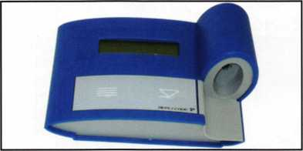

For over 235 years, the Bianchi family has been a constant pioneer in the locksmith industry, beginning in the Cadore Valley of Northern Italy in 1770. Through five generations, the company evolved into a full-line manufacturer of keys and key cutting machines and began distributing worldwide in the mid 1900's. Bianchi products first landed in North America in the early 1980's and the first independent presence in the market came in 1989 when Massimo Bianchi expanded his Italian company, Silca, into the US. Following mergers in 1997 with the Canadian Unican Group and 2001 with the llco/Kaba Group, Massimo Bianchi left the organization and re-emerged with the acquisition of KeyLine, an Italian manufacturer of keys and key cutting machines in April of 2002.

In February of 2003, another big step was made when Bianchi USA, Inc. opened its doors and became the North American presence for KeyLine and the Bianchi line of products. Bianchi USA sells both Bianchi and private branded products and specializes in key cutting machines and transponder servicing

**LASER**

A BIANCHI1770GROUP Company

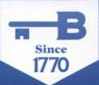

**BIANCHI 800.891.2118**

**USA, Inc. [www.bianchi1770usa.com](http://www.bianchi1770usa.com)**

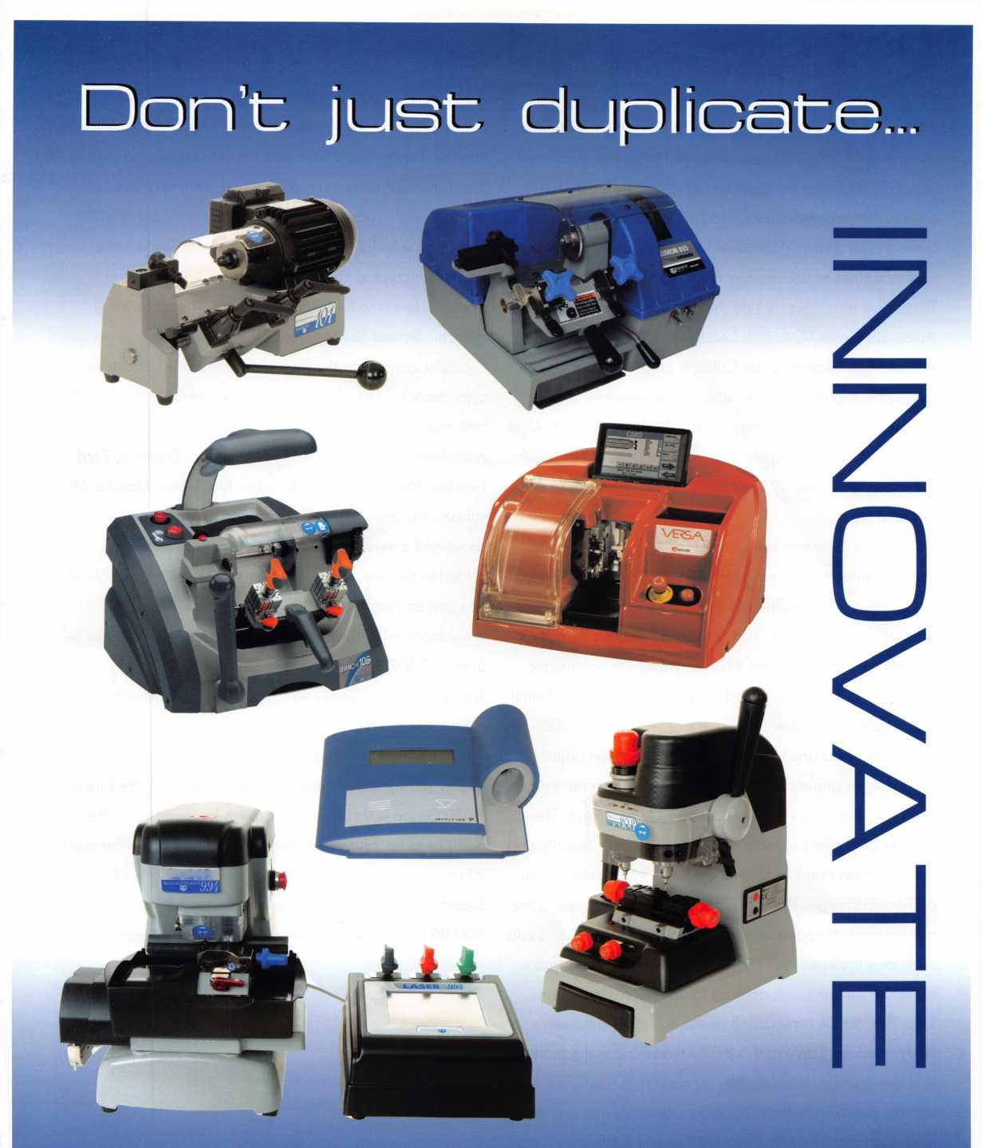

tools as well as a range of automotive transponder and non-transponder keys.

Since its inception, Bianchi USA has experienced tremen­dous growth. In 2003, there were just three key machines in the product line; the Bianchi 101 Manual, Bianchi 104 Semi-Automatic and Bianchi 303 High Security Duplicator. Since 2003, Bianchi has developed and added several new machines to accompany the three flagship machines. These new machines include the 095 Automatic, 106 Semi- Automatic, Laser 994 High Security Code Cutter, the VERSA High Security Code Cutter & Engraver and most re­cently, the Repli-Code 7 TX, which is an upgrade to the original Repli-Code 7 Transponder Programming Tool. All of the machines are designed and manufactured in Italy, with the exception of the 095, which is the first machine to be made in the USA.

Each Bianchi machine is known for its exceptional quality and craftsmanship. The Bianchi 101 is a sturdy basic dupli­cator with a small profile which makes it ideal for a van or small shop. The Bianchi 104 has been replaced with the Bianchi 106 machine and this heavy-duty semi-automatic duplicator is all you will need to cut commercial, residential and single and double sided automotive keys. The 106 also features a redesigned cutter blade that has been adjusted for a steeper angle cut in order to better cut specific keys like Titan, Best and older style General Motors keys. The Bianchi 303 offers reliable duplication for high security and laser style keys and includes the Audi/VW adaptors at no additional charge. The Bianchi Laser 994 is considered the most advanced code cutting machine in the market and cuts high security/laser keys by code, decode or depths and is a stand alone unit with an easy to use touch screen con­sole. The VERSA is regarded as the complete locksmith's utility machine (LUM) and is the first machine in the market that sequentially decodes, cuts by code and duplicates high security and dimple keys for both automotive and architec­tural and marks by engraving the head of the key.

To round out the key machine line, Bianchi also offers two

transponder service tools; the TD-3000 and the Repli-Code 7 TX. The TD-3000 is a transponder detector and is a handy and economical way for security professionals to de­termine if a key has a transponder. The Repli-Code 7 TX is a transponder programming tool and is an upgrade to the original Repli-Code 7 model that was introduced in 2005. The TX now features the ability to program Texas Instru­ments® encrypted code keys as well as the fixed code transponders. The Repli-Code 7 TX is compatible with Bianchi, Jet and Strattec clonable keys.

Finally, continuing the tradition started over 2 centuries ago, Bianchi USA offers a range of automotive transponder and non-transponder key blanks, which include keys for manufacturers like Audi, Chrysler, Dodge, Daewoo, Ford, General Motors, Honda, Hyundai, Kia, Lexus, Mazda, Mit­subishi, Porsche, Subaru, Toyota and Volkswagen as well as several others and new keys are consistently being added to the line. A complete listing of the keys Bianchi of­fers can be found at

[www.bianchil770usa.com/products.asp](http://www.bianchil770usa.com/products.asp). You can also re­quest a 2007 Transponder Key Guide or 2007 Non- Transponder Key Guide which offer a key chart with manufacturer's cross references.

For over two centuries, the Bianchi name has stood for quality products and innovative technology and the Bianchi 1770 Group will continue its growth by focusing on the goals of today and the opportunities of tomorrow. For more information on Bianchi USA, Inc. products or any of the Bianchi 1770 Group companies, please call 800.891.2118 or visit [www.bianchil770usa.com](http://www.bianchil770usa.com).

**16**

Keynotes • October 2007

JUNE 15-22, 2008 • DALLAS, TEXAS

and expose you to some of the best security-related tech­nology the industry has to offer.

Having built an international reputation among locksmiths as a powerful resource to ex­plore industry alliances, ALOA 2008 is the ideal place to learn, network or showcase your business on the show floor.

**For more information about Dallas, Texas please visit: www. dallascvb. com/visitors**

|  |  |  |  |  |  |
| --- | --- | --- | --- | --- | --- |
|  |  | boots! In 2008, we are cele- | brating the 52nd annual ALOA | * Kick-Off Party * ALOA Golf Tournament |  |  |
| ; |  | Convention and Expo in Dal­las, Texas. ALOA 2008 of- | * Tour * Banquet | j |  |
| It** | L J | 1 fers plenty of exciting classes and seminars that will educate | ★ Networking | i |  |

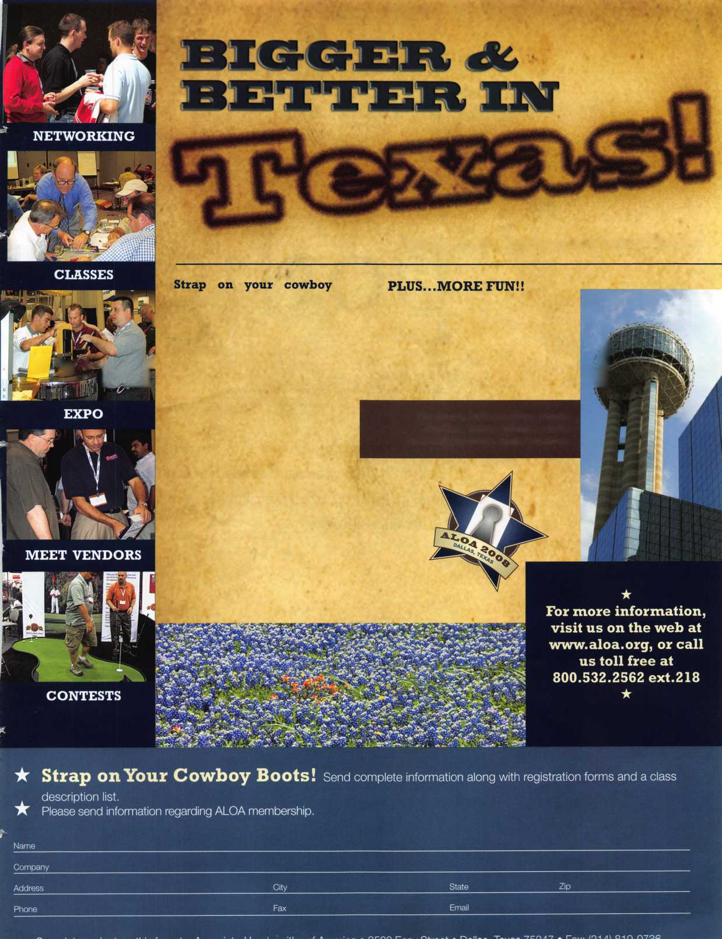

V



Welcome to our new monthly feature! Each month we will highlight a current ALOA member & their lockshop with a short bio and in-depth questions. To be considered or to recommend a fellow ALOA member please send an email to [betty@aloa.org](mailto:betty@aloa.org).

effrey Owens is the Owner/President of Greenwood Locksmith, Inc. and current President of the South Car­olina Locksmith Association. He has been a member of ALOA since 2002.

Greenwood Locksmith, Inc. 416 Woodlawn Road Greenwood, SC 29646

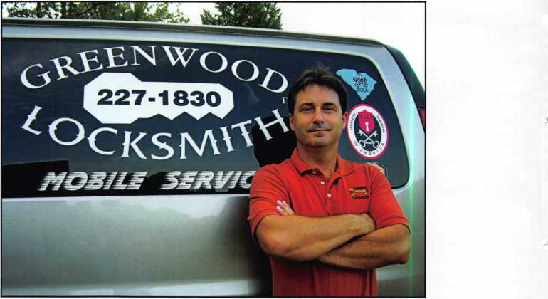

1. Tell us about your background in security and your experi­ence in locksmithing.

Jeffrey: I have been involved in Locksmithing for 18 years, the last six as Owner/President of Greenwood Locksmith, Inc. I have a B.S. in Business Administration from Lander University and a Certificate of Management from the University of South Carolina. I am the current President of the South Carolina Locksmith Association-SCLA.

***“The Locksmith of the "future" will need continuous training to keep up with technology.. ”***

1. What was your starting point in the security industry?

Jeffrey: I started working part- time for a local shop to earn some extra money, and soon found a great passion for the trade.

1. How long have you been a member of ALOA?

Jeffrey: I have been an ALOA member since 2002.

1. What made you decide to pur­sue a membership with ALOA?

Jeffrey: I wanted to take full ad­vantage of trade associations and an ALOA membership was one that had many benefits, includ­ing Keynotes and ALOA Con­ventions.

1. What benefit of ALOA has helped you the most?

Jeffrey: So far Keynotes has been my greatest resource related to ALOA. I have received knowl­edge from the articles, especially those on new products and ideas.I also like the member spotlight to see what others are thinking and doing.

1. What are the changes that you've noticed in the security technology recendy?

Jeffrey: I am experiencing more request from customers for elec­tronic related products in auto­motive and commercial markets. In automotive remotes and transponder keys, and in com­mercial electronic access control.



Keynotes • October 2007

1. What do you see as the future of security and where do you think are we headed in today's age of technology?

Jeffrey: I believe that we will always have me­chanical products to service and install, but there will be an expanding market for elec­tronic products to service and install. The Locksmith of the "future" will need continu­ous training to keep up with technology, and I believe that the internet is going to become even more valuable for training and even daily information needed to sell and service to our customers. I also believe that relationships with other locksmiths is going to become more of a necessity to operate a successful locksmith business, as a result ALOA and state associa­tions will grow in membership as we see the need to share information and receive training. The public is going to look for and will need a well informed, professional locksmith.

1. How do you stay informed about new prod­ucts and security techniques? (i.e. maga­zines, conventions, classes, etc.)

Jeffrey: I subscribe to many trade publications, including Keynotes, and I am active in the SCLA- South Carolina Locksmith Association- of which I am the current Prsident. The SCLA has quarterly meetings which include training classes and fellowship activities. I also attended the recent ALOA convention in Charlotte and visited every booth to gain as much informa­tion as possible.

1. How has life changed for you as a security professional in the past year?

Jeffrey: I have received more request for elec­tronic access control, which has caused me to read and study more in this field, and have in turn had increased sales and installation in this area.

1. What do you like most about your job?

Jeffrey: My favorite area has been the automo­tive market. I enjoy the challenge with transponders, remotes, and servicing automo­tive locks.

1. What advice can you give to an aspiring se­curity professional?

Jeffrey: You need to find out what markets are in your area and find out which markets inter­est you the most. If you can combine an area of interest with a growing market, then you will have a successful locksmith career.

1. Can you remember your first big security job? What can you tell us about it?

Jeffrey: Yes, it was installing an access control system at a large church on a children's min­istry building which was occupied by about 300 children and workers on Sunday mornings while the adults had a service in another build­ing. I used prox cards that had color coded and numbered lanyards to identify the different classes, when parents dropped off their child they received a prox card that was used to reenter the building and pickup their child. The children had wrist bands that were also color coded and numbered to match the par­

Keynotes • October 2007

ent with the child. It worked great and the parents had a sense security while their child was there.

1. As the president of the South Carolina Locksmith Association what do you feel is the state of the industry in these times?

Jeffrey: I believe that we are entering a new season in our industry in which the public is going to look more and more for a security professional. This will in turn cause us to seek relationships with other security professionals through associations-like ALOA, SCLA and others- to look for training classes and materi­als to help us be/stay security professionals.

1. Have you personally run into issues with bump keys which have recently been fea­tured in the news? How do you feel about this issue?

Jeffrey: I have had very few concerns about bump keys, the main concern came from the local sheriff department. I believe that the av­erage criminal is going to look for an easier entry, say for example a "brick" maybe. As pre­caution we should offer the customer bump- resistant products, especially as they are becoming more available.

1. What changes do you feel need to be made in the industry to prevent phony locksmiths from taking advantage of customers?

Jeffrey: I think that licensing by every state should be mandatory, but it must be done to protect the security professional as well as the public.

1. What do you think is the biggest obstacle facing security professionals, if any?

Jeffrey: I believe that our changing technology is our biggest issue to deal with, trying to "keep up" is a constant issue for every security professional. I recommend that all security professionals join ALOA, their state associa­tion (start one if you dont have one), and every professional association that relates to your markets, because current information and continued relationships with other security professionals are the "keys" (sorry for the pun) to being a successful security professional.

1. What is your favorite place in South Car­olina?

Jeffrey: My hometown, Greenwood. I am very blessed to live in such a great community.

*You must be a current member of The Asso­ciated Locksmiths of America in order to be recommended for our Member Spotlight fea­ture. If you would like to be recommended or would like to recommend someone else please email our Keynotes Editor, Betty Southerland at [betty@aloa.org](mailto:betty@aloa.org)

Keynotes • October 2007

A Look Inside the SmartKey

By Greg Perry, CML, CPS

Last month, September 2007 Keynotes, John Nassour gave us a first look and a way to make a key for the new Kwikset SmartKey. This month let’s look inside and see how this lock operates and what to do if we disassemble one.

First a few notes about this cylinder: this cylinder should normally never need to be disassembled but our shop tech­nician took one apart by mistake and chances are so will one of your coworkers or maybe even you; Kwikset claims the cylinder to be bump key resistant; I believe, because of it s sidebar design, it is pick resistant to conventional pick­ing (editors note: their advertising says that it has passed the UL437 picking tests, however it is not a UL437 listed lock).

I should clarify that the names for the parts used in this ar­ticle are not from Kwikset but rather names IVe assigned to the parts since Kwikset has not put out any information to our trade that I have found. From the outside it looks like most other Kwikset locks with a slight difference. The face of the cylinder has a 1/16” slot parallel to and just to the bottom left side of the keyway. This slot is for the rekey tool which is simply a .020 thick shim used to push the combination carriage back once the key has been turned clockwise 90 degrees. This position might be equated to a neutral position similar to what occurs in a Kaba-Simplex combination chamber. Turning the plug back without a key will set it to operate without a key. I rekeyed it to a key cut with all sevens and the plug turns with a key cut to

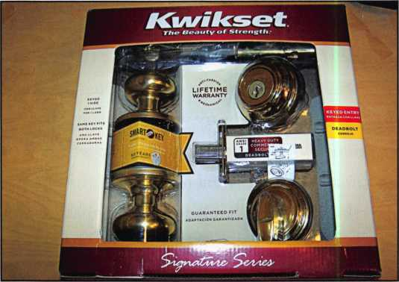

photo. 1

photo.2a11

sixes. Set it to all sixes and the plug doesn’t turn without a  
key. I wondered what would happen if it was set to a  
poorly cut copy, or how well a poorly cut key would oper-  
ate. To my surprise it worked fine - well sort of, at .005”  
to .010” deep the key worked well, at .015” it worked with  
a click in one direction but not the other consistently. This  
was the same when both setting and operating the cylinder  
after setting it to a good key. It even turned occasionally at  
.020” and .023” deep which is interesting since Kwikset  
uses a step distance of .023”. When cutting the key shal-  
low or not as deep, the lock worked up only .005” shallow.

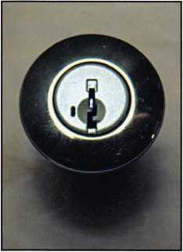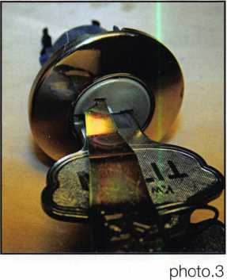

Keynotes • October 2007

1. ALOA Index of Documents (1 pg)
2. Reasons to Join ALOA (2 pg)
3. Locksmith Career Summary (3 pgs)
4. Locksmith School List (1 pg)
5. ACE Class Schedule (1 pg)
6. Certification Information (5 pgs)
7. PRP Category List (1 pg)
8. ALOA Membership Application (1 pg)
9. ALOA List of Benefits (1 pg)
10. ASF Scholarship Application (1 pg)
11. ASF Scholarship Information (1 pg)
12. ALOA Video Library Order Form  
    (1 P9)
13. Safe & Vault Technicians Associa-  
    tion Membership Application/Sub-  
    scription Form

(2 pgs)

1. Recertification Information (4 pgs)
2. Legislation Action Network Newslet­ter (2 pgs)
3. Various State Law Issues (8 pgs)
4. Industry Position Paper (1 pg)
5. ALOA Convention Class Schedule (3 pgs)
6. ALOA Convention Class Descrip­tions (30 pgs)
7. ALOA Convention Registration Forms (4 pgs)
8. Board of Directors Nomination Form (2 pgs)
9. ALOA Company Membership Appli­cation (2 pgs)

ALOA continues to provide  
you with this and  
other great benefits  
and services!

310-575-5027

nccu IIMIIHU

in a hurry?

Use AlOA’s Fax On De  
mand service.

Just call 310-575-5027 and receive:

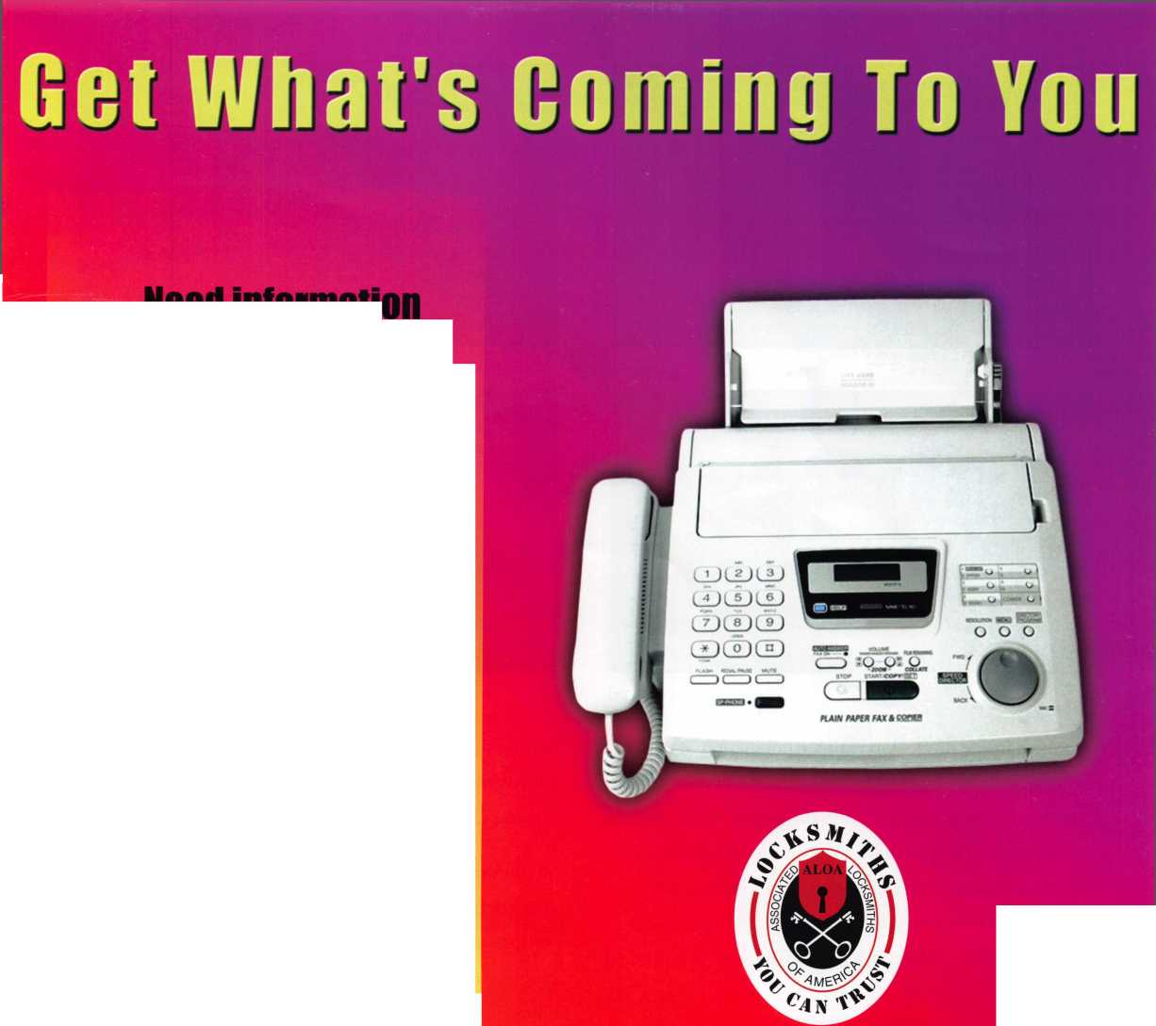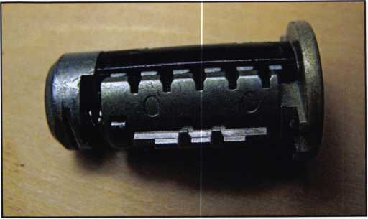

photo. 4 photo.5

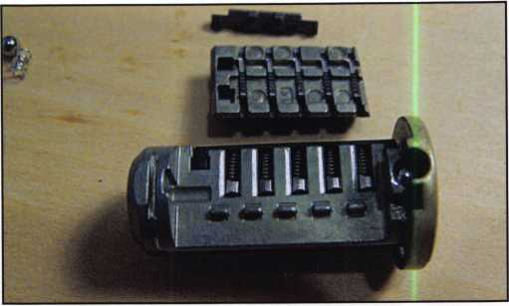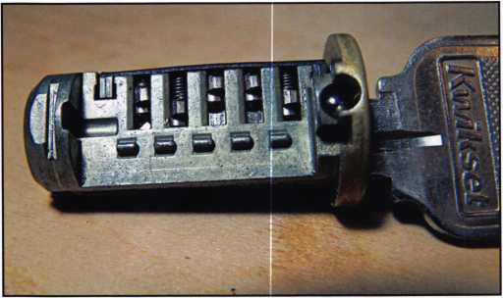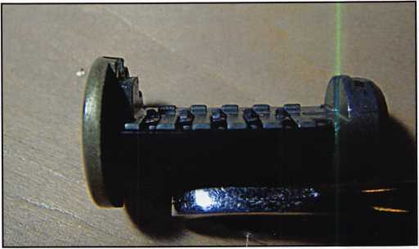

photo.6

Looking inside this lock reveals a combination of designs. The cylinder has five hollow pins that contact the key. It also has five springs that fit into the hollow of the pins, but no top pins. The pins have a tab on the side to transmit the up and down movement to the five sidebar discs or plates. The plates are small at .337 tall, .090 wide and only .031 thick with serration or small teeth on both sides. The inside or pin side is designed to seat into the tabs on the pins. This is how the combination is set. The outer side appears to add false gates or gaps to aid against pick­ing. The plates are placed in the carriage and move freely up and down when the tabs on the pins move them. The side bar sits on the outside of the carriage. It is pushed into the plates as the plug is turned; if the plates are set to the correct combination the side bar will enter the plates and allow the plug to turn. In addition instead of a stan­dard cylinder housing this lock has a sleeve surrounding the plug that allows for the movement of the plates and this is what the side bar locks into. A positioning ball



photo.7

bearing sits loosely on the opposite side of the plug. It will fall out as the plug is removed and can be lost in a second if you’re not careful.

So can this lock be picked or can it be bump keyed? Prob­ably not in the standard sense just like a GM or Ford side- bar lock will not pick with standard tools. It’s the same problem with any sidebar, binding the plug by turning it binds the sidebar from entering the sidebar discs. It can possibly be bypassed or picked by drilling for the end of the sidebar and putting a little pressure on it to enter the wafers but this will destroy the face cap and the false serrations on the plates will impede your efforts. Other options include the use of a cylinder puller like the Quick Pull (part number QP from A-l Mfg.) Another option is to drill out the side bar. This might give you a little trouble since Kwikset places a ball bearing right in front of the sidebar. If you choose to drill for the sidebar it’s in­line with and just above the change key hole centered on the plug.

Keynotes • October 2007

progress.

noun | pragr s; prag res; pr gres|  
forward or onward movement toward a destination

**Coming soon to [www.aloa.org](http://www.aloa.org)**

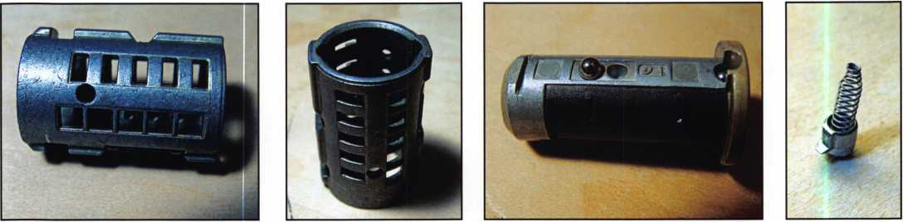

photo.8 photo.9 photo. 10 photo. 11

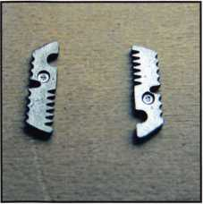

photo. 12

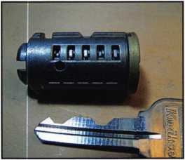

photo. 13

photo. 14

photo. 15

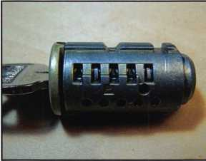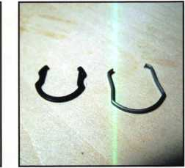

Servicing this cylinder without keys is difficult. The plug only comes out with the key inserted. If you take out the sleeve, use the method described last month by John to make the first key. If you do find yourself with this cylin­der on the bench in pieces, reassembling it can be done with patience. Start by replacing the side bar plates into the carriage and then align them with the groove towards the bottom of the carriage. Set it aside for a moment. In­sert a key into the plug. Hold the plug at an angle with the face up. Place the carriage spring on the plug and in­stall the carriage using care not to disturb the plates. Slide it back on the plug. This should set the plates to a neutral position. Insert the side bar and hold it as you start the next step. Now start to insert the plug into the sleeve. Turn the assembly over and install the ball bearing as you move it. With luck the plug will slide all the way in and set the combination to the key in the plug. If not, then start over and reset the side bar plates to the bottom locations.

Kwikset’s SmartKey is here to stay and I’m certain we will be getting calls to open and service it. At this time it looks like opening it without keys will require replacement cylin­ders or complete locks. If you need to replace a knob cylinder a standard part number 1850 cylinder for the 400 line of locks slip right in to the knob. Deadbolts will re­quire a whole cylinder from the 780 series. But before re­placing the cylinders like this, an ethical question needs to be answered. Is it appropriate to replace a bump key resist­ant and owner rekeyable cylinder with one that is not equal in security and customer convenience? They pur­chased a higher level of security and if you replace it with a lower level, I believe you need to at least let them know what you are doing. Over time you’ll probably get to see these cylinders for both service and opening. When you do, you won’t be caught off guard and you will be able to properly service this lock.



Keynotes • October 2007

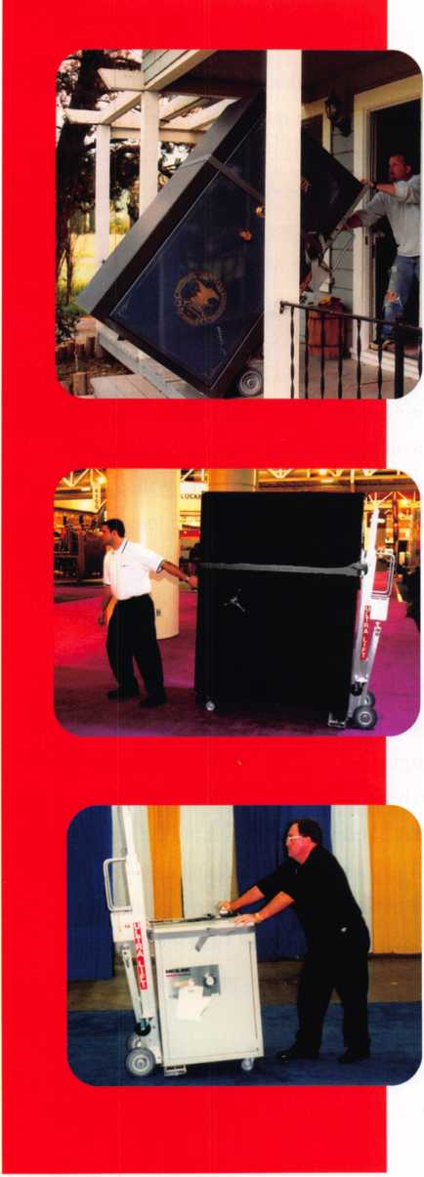

**GUMPS'**

T.M.

***OPERATOR SAFETY***

Injuries can be virtually eliminated. Ultra Lift does the lift-  
ing so that operator effort required to complete a move is  
minimized. Heavy loads are broken back with ease. The  
operator stays in control by using a combination of motor  
power, balance and leverage in every phase of a move.

***REDUCE LABOR COSTS***

Fewer people are required for any move with Ultra Lift.  
Manpower can be scheduled more productively. Labor  
savings often pay for the Ultra Lift in one month.

***ELIMINATE DAMAGE***

Loads are broken back, set down and moved under power  
with maximum leverage and operator control. Gentle  
handling eliminates bumps, bounces and damage to the  
load and premises.

***INCREASE PROFITS***

Increased operator safety, reduced labor cost and elimina-  
tion of damage to the load and premises all contribute to  
significant increases in profits.

FOR LITERATURE, VIDEO OR ON-SITE  
DEMONSTRATION, WRITE OR CALL:

ULTRA LIFT CORPORATION

475 STOCKTON AVENUE, UNIT E  
SAN JOSE, CA 95126  
800-346-3057  
408-287-9400  
FAX 408-297-1199  
E-mail: [info@ultralift.com](mailto:info@ultralift.com)  
**[www.ultralift.com](http://www.ultralift.com)**

**U.S. PATENT 4.570.953**

HIGH PERFORMANCE POWERED HAND TRUCKS

ULTRA LIFT supplies the power — so you don't have  
to. One person can safely and easily handle loads  
that usually require 2 or 3 people, even up or down  
stairs. Two people can handle most safes to 1500  
pounds. If safety is your concern, ULTRA LIFT is the  
best move you'll ever make!

Wild Goose (RELOCK) Chase

By Greg Perry, CML, CPS

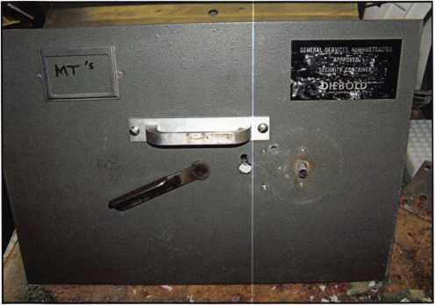

Photo 1 is how the handle would look normally locked.

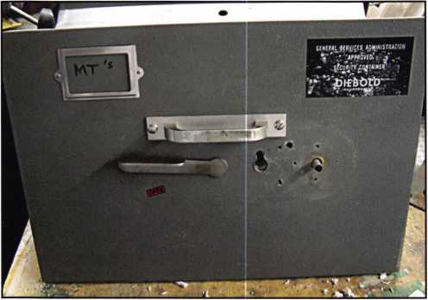

Photo 2 is the normal location when the drawer is unlocked.

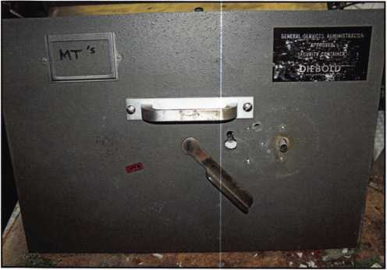

Photo 3 shows the handle in the location that I  
found it when I started this opening.

The first requirement in any opening is to define the actual problem. The second is to take the correct course of action.

This time I defined the problem almost correctly. If I had a mounted sample lock with me, I believe the problem would have been correctly diagnosed. So here’s the prob­lem: customer’s safe is a Diebold Class 2 GSA file safe. After dialing the combination correctly, the X-07 displays OP and stops, but the handle won’t turn. The handle cam was stripped out in an attempt to force it open. What is the most likely problem? Since the safe was being re­placed and they only needed it opened to remove the con­tents, this opening was a little easier than if the customer wanted the safe to be in service after the opening. Also this is a GSA Class 2 safe so the only allowable place to drill is under the dial, unless the safe is no longer going to be used to store classified materials. So have you guessed the problem yet? Perhaps it is a fired relock, but internal or external?

Let’s look at the way an X-07 operates. Dial the combi­nation: left, right, left to the actual numbers, and then turn it back to the right to get the OP symbol. Continue turn­ing right and when a magnet on the drive cam passes a reed switch on the body a signal is sent to the motor to start turning. The gear teeth engage, and as you continue to turn the dial/drive cam it starts to move a slide that pulls the lever into the drive cam. Then the drive cam takes over and pulls the bolt back very similar to most mechanical safe locks.

Remember this is a Diebold Class 2 GSA file safe. In general GSA means no external relock, and this file safe

**28**

Keynotes • October 2007



Craft

your own career

in Locksmithing

Learn to be a locksmith at our conveniently  
scheduled hands-on morning program. Classes  
are given from 7:30 am - 12:30 pm. Over nine  
months you will learn to service, install and  
bypass a wide variety of locking devices including

residential, commercial and automotive locks. Master keying, electronic  
access, and safe manipulation round out a curriculum which is updated  
annually to incorporate the latest industry advancements. September and  
February admissions.

Other full-time courses offered are • Bookbinding • Cabinet & Furniture  
Making • Carpentry • Preservation Carpentry • Jewelry Making & Repair  
• Piano Technology • Violin Making & Repair

Financial aid is available for qualified students. Accredited member ACCSCT. Non-accredited workshops 1 week to 3 months also offered.

**NORTH-BENNET-STREET-SCHOOL**

AN EDUCATION IN CRAFTSMANSHIP 39 North Bennet St. • Boston, MA 02113 • (617) 227-0155

[www.nbss.org](http://www.nbss.org)

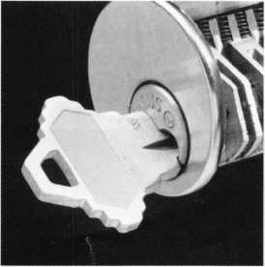

never came with an external relock. I checked a different safe with an X-07 and found the dial turns about 90 de­grees from when the bolt is fully retracted to when the bolt is fully extended which also is indicated by the sound of the fence clicking out of the drive cam. This lock only turned about 60 degrees. It sounds and feels like an inter­nal relock. So where is the best spot to drill? An X-07 can be drilled in several places. I use the StrongArm templates, an old dial or one of the available templates that show the numbers to determine the location. The first option is to drill for the motor gear 1 7/16” at 63 for a RH mounted lock, but in this case it doesn’t make sense since we have the combination and the fence drops into the drive cam. The other reason not to drill for the motor gear, in this case, is if the internal relock is fired then the motor gear location will not work because it is no different then turn­ing the drive cam with electronics after getting the OP sign. The second option is to drill for the lever or fence screw 1 11/16” at 25 for a RH mounted lock. The third choice is to drill for the lever pin 1 1/8” at 38 for a RH mounted lock. This is a great location to drill in this case because it bypasses the internal relock. The fourth option is to drill directly for the relock 1 9/16” at 87. This is the choice I made. This safe drilled easily with StrongArm carbide bits until the inner most layer of hardplate. Then the inner plate drilled easily with diamond core drills. Looking in with a scope I could see the fence drop into the drive cam and stop. It was about this time I realized that I was on a “wild goose” or relock chase. The internal relock had not fired!

So if the internal relock wasn’t fired then what was stop­ping the bolt retraction? I’m considering two possibilities. First the magnetic relock has fired. This is a pin in the bolt itself that fires in the event a strong magnet is placed in the vicinity of the bolt. The second is a motor gear problem that is , preventing the cam from turning. My next decision was where to drill the next hole? I chose the end of the bolt since this would confirm whether the bolt

Photo 4 shows the back of the drawer head. The  
back cover plates for the lock were missing. Since the  
container would not meet specification without them, re-  
moval from service would have occured even if  
the container had been repairable.

Photo 5 takes us a little further into the container  
with the back of the lock removed.

Photo 6 show the lock mounting surface with the 3 holes  
drilled, two at the bolt and the third for the relock.

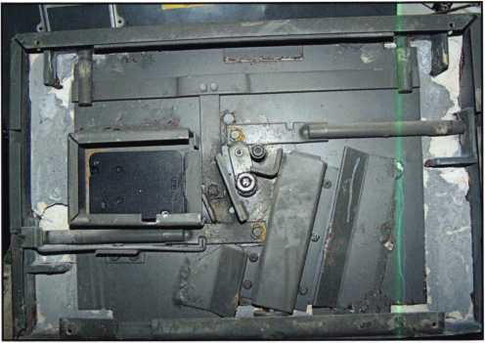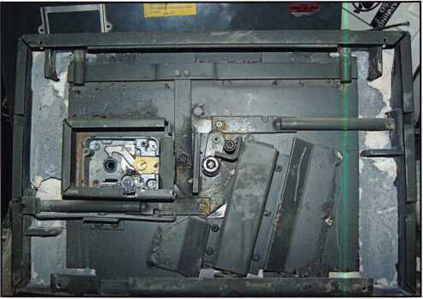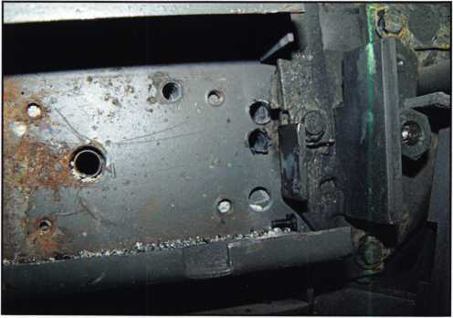

Keynotes • October 2007

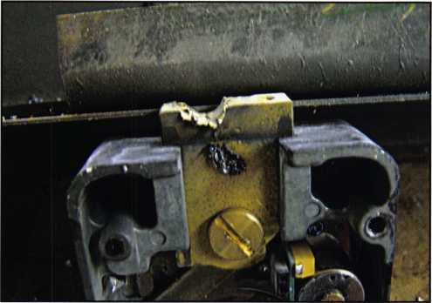

Photo 7 shows the end of the bolt showing where  
the punches created a divot in the end.

was actually retracting or not and this would also allow me to pry on the bolt. Through this hole, I was able to confirm that the bolt was not retracting and I could also pry the bolt back, but not quite far enough. The handle cam scrapped against the end of the bolt as it rotated, but because they had stripped the connection it would not quite go past. It was time to enlarge the hole to reach the handle cam. I started this procedure, but after reaching the inner most hardplate, I found it still needed to be dia­mond core drilled. Since I did not have a 1/2” diamond core drill or the ability to turn it since it requires a fixed rig and the largest the MiniRig can handle is 5/16”, I abandoned this procedure and chose to drill a third hole at the cam to pry it down. This proved to be successful and finally it was unlocked. I then instructed the cus­tomer to open then open the drawer.

It’s rare that I open safes after unlocking them. Some may claim this is semantically the same but really when you think about it, we don’t have a need to know what’s inside. That’s the customer’s realm. In this case there were classified materials inside. Most government or GSA safes are the same, only a person with a need to know and the appropriate level of security clearance is al­lowed to open the safe. For this reason any time you are working on a safe with classified materials you should never be left alone and after unlocking the safe, you should instruct the customer to open the safe.

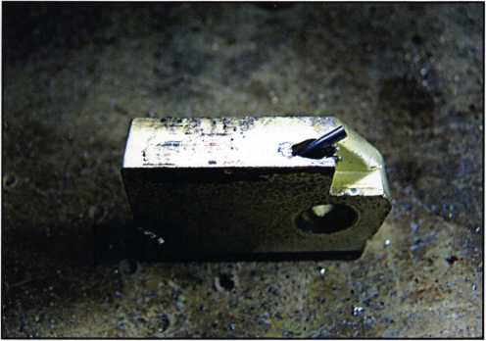

Photo 8 show the lock bolt with the magnetic  
pin sticking out of the side of the bolt.

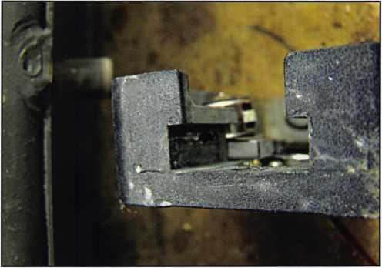

Photo 9 shows the hole in the lock  
case for this pin to go into.

So did you identify my wrong assumption and realize why having a lock with me would have prevented me from going on the wild relock chase? A lock in my hand would have allowed me to see the difference in dial movement between the two relocks. The internal relock on the slide only allows the dial to turn about 10 degrees. The magnetic relock allows more movement because the slide is moving and pulls the fence into the drive cam be­fore blocking any more movement. I guess I was a little off my game that day. I should have realized the internal relock wasn’t fired. Remember to take a lock or have the information with you on how far a dial should move if you suspect a relock problem. It just might save you from a wild relock goose chase.^



ongratulations to the following members who  
are the winners of the $100 American Express  
Gift Card:

* Andy Lavoie, Mt. Pleasant, NC
* Clay A. Hart, CRL, Parma, OH
* Christopher T. Picerno, CPL, Charlotte, NC
* Gary M. Condray, Pell City, AL
* Edward Henning, Palatine, IL
* Mel Roseman, Coral Springs, FL
* Kenneth Pedersen, Grand Junction, CO
* John A. Speakes, Bowue, MD
* Maurice F. Hatfield, Brunswick, GA
* Robert Myers, Long Beach, CA

Our purpose was to under­stand the current levels of member satisfaction to ALOA programs and member benefits and identify our demographic makeup. Your participation has pro­vided us with some important insights on how you perceive the value of your membership including the identification of areas that you would like us to either enhance or provide.

The following is a summary of the key findings:

**Who are we?**

60% percent identified themselves as  
business owners

The majority work in the storefront and  
mobile work environment

1 in 3 is a “mobile only” locksmiths

49% have been in the industry 25 or more years

Majority use the internet and email daily

55% access the ALOA website monthly

**Summary of Findings**

Educational programs and other “traditional” mem-  
bership benefits are important. However, members be-  
lieve that enhancing the image of locksmiths among

the general public  
is ALOAs most  
important role.

Overall, the satis-  
faction level of  
members is not  
high, even with the  
increases of satis-

faction over the 2001 survey. In spite of the lower sat-  
isfaction scores on key ALOA programs, a higher  
percentage of ALOA members consider their member-  
ship to be of more valuable today than it was two years  
ago (29% more valuable versus 10% less valuable) and  
the same trend continues when they were asked if they  
expect their membership to be more or less valuable  
two years from now. Forty-two percent believe it will  
be more valuable in two years, while only 7% believe  
that it will be less valuable.



“Thank you to everyone who participated in the 2007 Membership survey! We would not have been able to accomplish our goal without your support!”

Keynotes • October 2007



As a result of these findings we will be working on raising the satisfaction beginning with those which have been identified as the most important and with the lowest level of satisfaction. The following are some of the initiatives that have been identified:

**Enhancing the image of locksmiths with the public**

Initiative One in support of End 4-Recognition:

Significantly enhance the content for consumers on the ALOA website. More in-depth information di­rected at consumers will not only enhance the image of ALOA, it will also provide more referrals to ALOAs certified locksmiths, which in turn enhances the value of membership.

Initiative Two in support of End 4-Recognition:

Undertake a public image campaign by coordinating a cooperative effort with manufacturers and other cor­porations in the security category. Taking the lead will also enhance the image of locksmiths and the integral role they play in the security industry.

Initiative Three in support of End 2-Communica- tion: Continue to increase the number of member “touch points” by using a combination of advertising in other industry publications, improvement of con­tent of the ALOA website, email communications and developing a member newsletter.

Initiative Four in support of End 3-Education:

Continue to develop educational offerings that are relevant to the industry and increase accessibility to these programs.

The insights provided by this survey will be used as the foundation of our focus in meeting member needs and expectations. In the next few months we will continue to work on the execution of these initia­tives as well as the development of future programs and benefits.

We are very excited about the opportunities that lay ahead and are pleased to know that we have your support.

For a more detailed report of the membership survey please visit the ALOA website at h ttp: //[www.aloa.org/](http://www.aloa.org/) images/memb_survey. pps

V

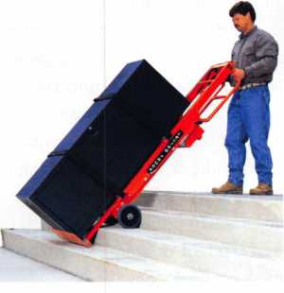

***LectroTruck***

1 STAIR CLIMBINCj SYSTEM  
Visit us online at:

[www.lectrotruck.com](http://www.lectrotruck.com)

...or call us today at:

800-619-0625

The Lectro-Truck will make it easier for you to break back a load, climb and descend steps, and even load onto your truck or trailer!

Save on damage costs.

Save on injury costs.

Save on labor costs.

The bottom line: You save money!!

The Lectro-Truck makes this all possible - all while having a 1500 # capacity!! Call us today to find out what you have been missing.

Keynotes • October 2007

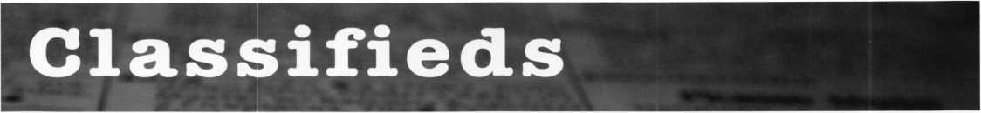

EMPLOYMENT

EXPERIENCED LOCKSMITHS

Join our staff at John Koons Locksmiths in Southwest Florida. Positions in one of our shops or outside service are available. We offer health insurance and vacation. Housing is also avail­able for qualified applicants. Call George Klein at 1-800-282-8458 or fax a resume to 239-931-6203. John Koons Locksmiths, 3526 Fowler Street, Fort Myers, Florida 33901.

SERVICE TECHNICIAN WANTED IN CHICAGO

Full time position, installing and servic­ing Access Control and Electronic Door Hardware, with experience only. Union job with excellent benefits. Please fax resume to 31 2-850-6701, attention: Pat or email [pglavin@glavin- lock.com](mailto:pglavin@glavin-lock.com).

No phone calls please.

LOCKSMITH WANTED

Busy shop in Woburn, Massachusetts seeks experienced Locksmith. We per­form commercial, residential, safe, glass storefronts, card access and au­tomotive work including 2 AAA ac­counts. You don't have to know all these phases of locksmithing and we are also willing to train if interested. Sub contractors welcome - your van or ours. For more info please contact John at 781-933-9999 or send re­sume to:

Locks & Keys, Inc., P.O. Box 222, Woburn, MA01801.

LOCKSMITH WANTED

Established company with 30+ years in business in Hampton Roads, Vir­ginia is seeking locksmith with experi­ence in residential, commercial, and automotive work. Knowledge in servic­ing safes, medeco locks and elec­tronic access control a plus. Applicant must be neat in appearance self moti­vated, have good driving record and be able to pass background and drug testing.

We offer full benefits package, com­petitive wages, medical insurance, paid vacation and sick days, educa­tion and profit sharing. Send resume to: Shorty Wallin Lock and Security. Fax 757-722-5520 or email to: [swallin@shortywallin.com](mailto:swallin@shortywallin.com)

LOCKSMITH TECH NEEDED

Need energetic Locksmith Tech with good working skills, computer experi­ence and warehouse skills a plus!!!!! Hours: Mon-Fri, 8am-5pm Good driving record required. Retire­ment Plan, Health Insurance, Salary Negotiable. Established, well known company in business since 1964. Sword Company, 6525 South Broad­way, Tyler, Texas 75703 Ph: 903-561- 1961. Send resume to Fax 903-561-4932 or email: [mike@swordco.com](mailto:mike@swordco.com)

SALES PERSON NEEDED

Nevada Lock Supply, a wholesale lock supply company located in beau­tiful Las Vegas, seeks a front counter sales person. Must have 2 years of lock experience and good communi­cation skills. Competitive salary and benefits package. Contact John at [jmiers@nevadalock.com](mailto:jmiers@nevadalock.com)

LOCKSMITH - STORE MANAGER WANTED

New Locksmith store opening October in Aventura, Florida. We are looking for an experienced locksmith to run the store. Great opportunity for the right person. Qualifications: Experi­enced Locksmith and knowledgeable about hardware. Retail store experi­ence. Can do estimates and sell jobs. Interact and communicate well with clients. Bilingual - English/ Spanish. Self-starter and problem solver. Lock­smith's License, Driver's License.

Salary Open. Email: [aviva@soslockmith.com](mailto:aviva@soslockmith.com)

LOCKSMITH WANTED NYC

Experienced Locksmith and knowl­edgeable about hardware. Can do es­timates and sell jobs. Interact and communicate well with clients. Lock­smith's License, Driver's License. Man­hattan Location. Salary Open. [aviva@soslockmith.com](mailto:aviva@soslockmith.com)

LOCKSMITH OR APPRENTICE - BOZEMAN, MONTANA,

THE BEST PLACE

Bozeman Safe & Lock is a provider of security hardware, systems, and serv­ices in the south central region of Montana. We are the region's market leader in developing professional and effective security soluctions to diverse commercial, residential, and safe problems. Consider being part of our team! Visit our website at [www.boze- mansafeandlock.com](http://www.boze-mansafeandlock.com). Appropriate certification(s) a plus. Competitive salary, benefit package. Call Rich at 406-570-51 34 or email: [rich@boze- mansafeandlock.com](mailto:rich@boze-mansafeandlock.com).

Keynotes • October 2007

EXPERIENCED LOCKSMITH NEEDED - SIGN-ON BONUS RELOCATION ASSISTANCE

60 year old Austin, Texas company with 5 locations and 29 service vehi­cles is seeking experienced technicans as well as shop management candi­date. We offer competitive wages based on experience, commissions, overtime, medical benefits, 401k, cafe­teria plan, paid vacations, sick leave and holidays. We supply the vehicle and tools, you supply the talent. Our customers are residential, commericial and industrial and institutional. We also do access control, CCTV, and alarms. Opportunity for education, growth and advancement is tremen­dous. The right candidates will be given a 'sign on" bonus. Relocation as­sistance is also available. Must be able to meet requirements of State of Texas for licensing. If interested, send resume to: [jimh@cothrons.net](mailto:jimh@cothrons.net) or fax to 512-459-2828.

WANTED TO BUY/SELL

MOBILE LOCKSMITH BUSINESS FOR SALE

In Kansas City area. Well established with loyal customers. Strong with banks and schools. One person busi­ness with plenty of room for expansion opportunity. Great reputation! Owner retiring. Call Bob Badgley 1-800-966- 2005

LOCKSMITH BUSINESS FOR SALE

Locksmith Business for sale in beautiful Galveston Island, Texas. Address:

1624 21 Street, 77550. Owner retir­ing after 33 years due to health. Many commercial, residential, real estate, in­dustrial accounts. Very well estab­

lished. Equipment and inventory in­cluded. Over 20,000 keys in stock. In­cludes 2001 Ford Club Econoline van, 2 Bravo Key Machines, 2 Curtis Clip­per's #15 all accessories for all cars and all car opening tools and much more. Two blocks from beach. Busi­ness is booming. More than we can handle. Business name only selling for $325,000 obo with option to buy property. Location corner lot with house on side of business. All for $599,000 firm. Please serious in­quiries only. Call 409-765-9551 day­time or 409-789-8487 only til 9pm Mon-Fri.

VJ. Tramonterealty.com 409-765-9837.

MOBILE LOCKSMITH BUSINESS FOR SALE

Mobile Locksmith Business for Sale in the thriving Coachella Valley in South­ern California. If you're an experi­enced locksmith with a current California locksmith permit, here's a chance to be in business for yourself.

Be your own boss and work towards your own dreams and goals instead of your employers'. For details, contact David, or leave a message at 760- 772-0153.

FOR SALE -

LOCKSMITH BUSINESS

Locksmith Business near southwest sub­urbs of Chicago (Evergreen Park/Oak Lawn area). Retiring due to health. Business includes many commerical and automotive accounts with twenty eight year customer base. Sale in­cludes telephone number, 2003 Dodge Sprinter with 63,000 miles, all equipment including Triax high security

machine Ultra Code Bravo key ma­chine, HPC 1200 with attacments for Tibbi key,

T code, NGS, tubular key machine, GM ten cut and six cut system and many tryout keys. Also includes Trip lite inverter, many priming kits (foreign and domestic) all cabinetry and stock merchandise. For further information and price all Frank at 708-422-4808.

FOR SALE

Medeco Manual Key Machine. Cuts both level I and II. Excellent condition - used. $2000 plus shippping. Code book included. Also used Scotsman Key Machine 747X. Cuts standard size keys only. $300 plus shipping. Call Joe Rick at AAA Distributors, Buf­falo, NY 716-856-2261.

8:30 a.m. - 5:00 pm EST

FOR SALE

3 HPC Machines: Trace A Key, Punch, Blitz, Opening tools Tryout keys, deter­minators, blanks, about $18,000 near new- need resonable offer. Call Al at 602-291-3500.

FOR SALE

Abloy disklock key cutting machine model 6200 with original instructions and 25 disc key blanks. No more than 100 keys have been cut on this machine which his in 'like new' condi­tion. Original price was $1775.00. Selling price $550.00 including ship­ping anywhere in the U.S. Richard Grudens, Edison Locksmiths, 425 North Country Road, St. James, New York, 11780, or [rgrudensl@aol.com](mailto:rgrudensl@aol.com) Fax 631-0139.

Classified Advertising Policy

Classified advertising space is provided free of charge to ALOA members and for a fee of $2.00 per word, $40.00 minimum for non members. Classified ads may be used to advertise used merchandise and overstocked items for sale, "wanted to buy" items, business opportunities, employment opportunities/positions wanted and the like. Members or non members wishing to advertise services or new merchandise for sale may purchase a "Commercial Classified Ad" for a fee of $4.00 per word with a minimum of $ 100.00. Each ad will run for two issues. For blind boxes there is a $10.00 charge for members and non members. All ads must be submitted in writing to the Advertising Sales Department via fax at 817-645-7599 or through an email to [adsales@aloa.org](mailto:adsales@aloa.org) by the fifteenth of the month two months prior to issue date. ALOA reserves the right to refuse any classified advertisement that it deems inappropriate according to the stated purpose of the classified advertising section.

**35**

Keynotes • October 2007



**associate**

members

Distributor

**1 st In Hardware, Inc.**

Phone: 410-646-9900 Fax: 410-646-0045 www. 1 stinhardware.com

**ADEL Fingerprint Technology, LLC**

Phone: 909-595-1222 Fax: 909-595-1667

**Accredited Lock Supply Co.**

Phone: 800-652-2835 Fax: 201-865-2435 [www.acclock.com](http://www.acclock.com)

**American Auto Lock.Com**

Phone: 717-392-6333 Fax: 717-581-8353 [www.americanautolock.co](http://www.americanautolock.co) m

**Boyle & Chase Inc.**

Phone: 800-325-2530 Fax: 800-205-3500 [www.boyleandchase.com](http://www.boyleandchase.com)

**Clark Security Products**

Phone: 858-974-6740 Fax: 858-974-6720 [www.clarksecurity.com](http://www.clarksecurity.com)

**CookAs Building Specialties**

Phone: 505-883-5701 Fax: 505-883-5704

**Dire's Lock & Key Company**

Phone: 303-294-0176 Fax: 303-294-0198

**Direct Security Supply, Inc.**

Phone: 800-252-5757 Fax: 800-452-8600

**Doyle Security Products**

Phone: 800-333-6953 Fax: 612-521-0166 [www.doylesecurity.com](http://www.doylesecurity.com)

**Dugmore and Duncan, Inc.**

Phone: 888-384-6673 Fax: 888-329-3846

**E. L. Reinhardt Co., Inc.**

Phone: 800-328-1311 Fax: 651-481-0166 [www.elreinhardt.com](http://www.elreinhardt.com)

**Foley-Belsaw**

**Company**

Phone: 800-821-3452 Fax: 816-483-5010 [www.foley-belsaw.com](http://www.foley-belsaw.com)

**Fried Brothers Inc.**

Phone: 800-523-2924 Fax: 215-592-1255 [www.fbisecurity.com](http://www.fbisecurity.com)

**H.L. Flake Co.**

Phone: 800-231-4105 Fax: 713-926-3399 [www.hlflake.com](http://www.hlflake.com)

**Hardware Agencies, Ltd.**

Phone: 416-462-1921 Fax: 416-462-1922 [www.hardwareagencies.com](http://www.hardwareagencies.com)

**IDN Incorporated**

Phone: 817-421-5470 Fax: 817-421-5468 [www.idn-inc.com](http://www.idn-inc.com)

**Instant Hardware Delivery, Inc**

Phone: 800-355-1 107 Fax: 800-663-8518

**Intermountain Lock & Security**

Phone: 800-453-5386 Fax: 801-485-7205 [www.imlss.com](http://www.imlss.com)

**Jovan Distributors, Inc**

Phone: 416-288-6306 Fax: 416-752-8371 [www.jovanlock.com](http://www.jovanlock.com)

**L V Sales Inc**

Phone: 323-661-4746 Fax: 323-661-1314 [www.lvsales.com](http://www.lvsales.com)

**Lockmasters, Inc.**

Phone: 859-885-6041 Fax: 859-885-7093 [www.lockmasters.com](http://www.lockmasters.com)

**Locks Company**

Phone: 800-288-0801 Fax: 305-949-3619

**Locksmith Ledger International**

Phone: 847-454-2700 Fax: 847-454-2759 [www.lledger.com](http://www.lledger.com)

**McDonald Dash Locksmith Supply Inc.**

Phone: 800-238-7541 Fax: 901-366-0005 [www.mcdonalddash.com](http://www.mcdonalddash.com)

**NLS Lock Supply Dba Nevada Lock Supply**

Phone: 702-737-0500 Fax: 702-737-7134

**Omaha Wholesale Hardware**

Phone: 800-238-4566 Fax: 402-444-1664 [www.omahawh.com](http://www.omahawh.com)

**Phoenix Safe International LLC**

Phone: 765-483-0954 Fax: 765-483-0962 [www.phoenixsafeusa.com](http://www.phoenixsafeusa.com)

**Positive Identity Solutions**

Phone: 704-663-1 175 Fax: 704-660-1301 [www.pids-usa.com](http://www.pids-usa.com)

**Red Hawk Industries**

Phone: 800-843-4810

**Security Distributors Inc**

Phone: 800-333-6953 Fax: 612-524-0166

**Southern Lock and Supply Co.**

Phone: 727-541-5536 Fax: 727-544-8278 [www.southernlock.com](http://www.southernlock.com)

**Stone & Berg Wholesale**

Phone: 800-225-7405 Fax: 800-535-5625

**The Locksmith Store Inc.**

Phone: 847-364-5111 Fax: 847-364-5125 [www.locksmithstore.com](http://www.locksmithstore.com)

**The Ultimate Distribution Company**

Phone: 254-681-2277 Fax: 254-953-4933 [www.ultimatelocksales.com](http://www.ultimatelocksales.com)

**Timemaster Inc.**

Phone: 859-259-1878 Fax: 859-255-0298 www. ti m e-m a ste r. co m

**Top Notch Distributors, Inc.**

Phone: 570-753-5625 Fax: 570-253-7178 [www.topnotch.bz](http://www.topnotch.bz)

**Turn 10 Wholesale**

Phone: 800-848-9790 Fax: 800-391-4553

**U.S. Lock Corp.**

Phone: 800-925-5000 Fax: 800-338-5625 [www.uslock.com](http://www.uslock.com)

Manufacturer

**A & B Safe Corporation**

Phone: 800-253-1267 Fax: 856-863-1208 [www.a-bsafecorp.com](http://www.a-bsafecorp.com)

**ABUS KG**

Phone: 492-335-634151 Fax: 233-563-4130 [www.abus.com](http://www.abus.com)

**ABUS Lock Company**

Phone: 800-352-2287 Fax: 602-516-9934 [www.abus.com](http://www.abus.com)

**Access Security Products Ltd.**

Phone: 905-337-7874 Fax: 905-337-7873 www. access-safe. com

**Accu-Key Lock &**

**Safe Inc**

Phone: 937-294-4241 Fax: 937-294-6565

**Adams Rite Mfg Company**

Phone: 800-872-3267 Fax: 800-232-7329 [www.adamsrite.com](http://www.adamsrite.com)

**Adrian Steel Company**

Phone: 800-677-2726 Fax: 517-265-5834 [www.adriansteel.com](http://www.adriansteel.com)

**Advanced Diagnostics USA Inc**

Phone: 650-876-2020 Fax: 650-876-2022 [www.autokeys.com](http://www.autokeys.com)

**Alarm Controls Corporation**

Phone: 631-586-4220 Fax: 631-586-6500 [www.alarmcontrols.com](http://www.alarmcontrols.com)

**All Five Tool Company, Inc.**

Phone: 860-583-1691 Fax: 860-583-4516 [www.all5tool.com](http://www.all5tool.com)

**American Security Products**

Phone: 909-685- 9680x2013 Fax: 909-685-9685 [www.amsecusa.com](http://www.amsecusa.com)

**Bianchi USA, Inc.**

Phone: 800-891-2118 Fax: 216-803-0202 [www.bianchi](http://www.bianchi) 1770usa.com

**Buddy Products**

Phone: 312-733-6400 Fax: 312-733-8356 [www.buddyproducts.com](http://www.buddyproducts.com)

**CCL Security Products**

Phone: 800-733-8588 Fax: 847-537-1800 [www.cclsecurity.com](http://www.cclsecurity.com)



Keynotes • October 2007

**associate**

members

**CompX Security Products**

Phone: 864-297-6655 Fax: 864-297-9987 [www.compx.com](http://www.compx.com)

**D&D Technologies (USA), Inc.**

Phone: 714-677- 1300x292 Fax: 714-677-1299 [www.ddtechglobal.com](http://www.ddtechglobal.com)

**DETEX Corp.**

Phone: 800-729-3839 Fax: 830-620-671 1 [www.detex.com](http://www.detex.com)

**Don-Jo**

**Manufacturing, Inc.**

Phone: 978-422-3377 Fax: 978-422-3467 [www.don-jo.com](http://www.don-jo.com)

**Door Controls International**

Phone: 800-742-3634 Fax: 800-742-0410 [www.doorcontrols.com](http://www.doorcontrols.com)

**Doorking Inc.**

Phone: 800-826-7493 Fax: 310-641-1586 [www.doorking.com](http://www.doorking.com)

**Dorma Architectual Hardware**

Phone: 717-336-3881 Fax: 717-336-2106 [www.dorma-usa.com](http://www.dorma-usa.com)

**DynaLock Corp**

Phone: 860-582-4761 Fax: 860-585-0338 [www.dynalock.com](http://www.dynalock.com)

**FireKing Security Group**

Phone: 800-457-2424 Fax: 800-896-6606 [www.fireking.com](http://www.fireking.com)

**Framon Manufacturing Company Inc.**

Phone: 989-354-5623 Fax: 989-354-4238 [www.framon.com](http://www.framon.com)

**G-U Hardware Inc.**

Phone: 757-877-9020 Fax: 757-877-9720 [www.g-u.com](http://www.g-u.com)

**HPC, Inc.**

Phone: 847-671-6280 Fax: 847-671-6343 [www.hpcworld.com](http://www.hpcworld.com)

**HY-KO Products Co.**

Phone: 330-467-7446 Fax: 330-467-7442

**Hammerhead Industries, Inc.**

Phone: 805-658-9922 Fax: 805-658-8833 [www.gearkeeper.com](http://www.gearkeeper.com)

**Ingersoll Rand**

**Security**

**Technologies**

Phone: 317-810-3801 Fax: 317-805-5779 [www.schlagelock.com](http://www.schlagelock.com)

**Jackson Corporation**

Phone: 323-269-8111 Fax: 800-888-6855 [www.jacksonexit.com](http://www.jacksonexit.com)

**Jet Hardware Mfg., Co.**

Phone: 718-257-9600 Fax: 718-257-0973 [www.jetkeys.com](http://www.jetkeys.com)

**KABA ILCO Corp.**

Phone: 252-446-3321 Fax: 252-446-4702 [www.kaba-ilco.com](http://www.kaba-ilco.com)

**KEY-BAK/West Coast Chain Mfg.**

Phone: 909-923-7800 Fax: 909-923-0024 [www.keybak.com](http://www.keybak.com)

**Kenstan Lock Company**

Phone: 516-576-

9090x315

Fax: 516-576-0100

[www.kenstan.com](http://www.kenstan.com)

**Keri Systems Inc.**

Phone: 408-435-8400 Fax: 408-435-7163 [www.kerisys.com](http://www.kerisys.com)

**Kustom Key Inc.**

Phone: 800-537-5397 Fax: 800-235-4728 [www.kustomkey.com](http://www.kustomkey.com)

**LAB Security**

Phone: 800-243-8242 Fax: 860-583-7838 [www.labpins.com](http://www.labpins.com)

**Lucky Line Products, Inc.**

Phone: 858-549-6699 Fax: 858-549-0949 [www.luckyline.com](http://www.luckyline.com)

**M.A.G.**

**Manufacturing**

Phone: 714-891-5100 Fax: 714-892-6845

[www.magmanufacturing.com](http://www.magmanufacturing.com)

**MPT Industries, Inc.**

Phone: 973-989-9220 Fax: 973-989-9234 [www.mptindustries.com](http://www.mptindustries.com)

**MUL-T-LOCK USA, Inc.**

Phone: 800-562-351 1 Fax: 973-778-4007 [www.mul-t-lockusa.com](http://www.mul-t-lockusa.com)

**Maxcess Card Systems Inc**

Phone: 800-713-4823 Fax: 650-692-9410 [www.maxcess-card.com](http://www.maxcess-card.com)

**Medeco Security Locks**

Phone: 540-380-5000 Fax: 540-380-5010 [www.medeco.com](http://www.medeco.com)

**Mil-Comm Products Co Inc**

Phone: 201-935-8561 Fax: 201-935-6059

**Pacific Lock Company**

Phone: 888-562-5565 Fax: 818-678-6600 [www.paclock.com](http://www.paclock.com)

**Protex Safe Co., LLC**

Phone: 818-610-8030 Fax: 818-610-8004 [www.protexsafe.com](http://www.protexsafe.com)

**RA-Lock Company**

Phone: 800-777-6310 Fax: 972-775-6316 [www.ralock.com](http://www.ralock.com)

**ROFU International Corp.**

Phone: 800-255-7638 Fax: 253-840-7272 [www.rofu.com](http://www.rofu.com)

**Rutherford Controls Int'l Co.**

Phone: 519-621-7651 Fax: 519-621-7939 www. rutherfordcontrols.c om

**Sargent &**

**Greenleaf, Inc.**

Phone: 859-885-941 1 Fax: 859-885-3063 www. sa rgenta ndg reen- leaf.com

**Sargent**

**Manufacturing Co.**

Phone: 800-727-5477 Fax: 888-863-5054 [www.sargentlock.com](http://www.sargentlock.com)

**Schwab Corp.**

Phone: 765-447-9470 Fax: 765-447-8278 [www.schwabcorp.com](http://www.schwabcorp.com)

**Securifort Inc**

Phone: 819-359-2226 Fax: 819-359-2218 [www.securifort.com](http://www.securifort.com)

**Securitron Magnalock Corp.**

Phone: 775-355-5625 Fax: 775-355-5636 [www.securitron.com](http://www.securitron.com)

**Security Door Controls**

Phone: 805-494-0622 Fax: 805-494-8861 [www.sdcsecurity.com](http://www.sdcsecurity.com)

**Security Solutions**

Phone: 405-376-1600 Fax: 405-376-6870 [www.securitysolutions- usa.com](http://www.securitysolutions-usa.com)

**Select Engineered Systems**

Phone: 305-823-5410 Fax: 305-823-5215 [www.selectses.com](http://www.selectses.com)

**Townsteel, Inc.**

Phone: 626-858-5080 Fax: 626-858-3393 [www.townsteel.com](http://www.townsteel.com)

**Trine Access Technology**

Phone: 718-829-2332 Fax: 718-829-6405 [www.trineonline.com](http://www.trineonline.com)

**Videx Inc.**

Phone: 541-758-0521 Fax: 541-752-5285 [www.videx.com](http://www.videx.com)

**WIKK Industries Inc.**

Phone: 414-421-9490 Fax: 414-421-3158 [www.wikk.com](http://www.wikk.com)

**WMW Innovation Company**

Phone: 888-474-2341 [www.sure-strike.com](http://www.sure-strike.com)

Service

Organization

**Allstate Insurance Company**

Phone: 847-551-2181 Fax: 847-551-2732 [www.allstate.com](http://www.allstate.com)

**HRH Insurance**

Phone: 817-462-3630 Fax: 817-462-3680 [www.hrh.com](http://www.hrh.com)

**Red Hawk**

Phone: 901-332-2911 Fax: 901-332-2878 [www.webstersinc.com](http://www.webstersinc.com)

**The Mechanic Group, Inc.**

Phone: 845-735-0700 Fax: 845-735-8383

[www.mechanicgroup.com](http://www.mechanicgroup.com)

Keynotes • October 2007

**3**

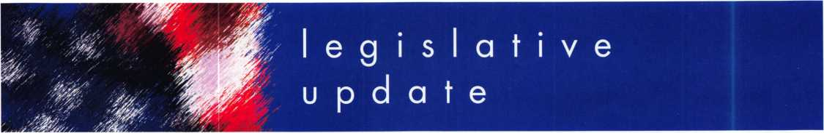

***KEYNOTES*** - ***OCTOBER***

2007 LEGISLATIVE HIGHLIGHTS

**ALABAMA H754/S508**

Adds fire alarms to the definition of alarm system and provide clarification concerning the exemption for electri­cal contractors. Failed.

**CONNECTICUT H7268**

Requiring the registration of electronic security alarm companies. Electronic security definition includes access con­trol and CCTV. Failed.

**HAWAII HI88**

Requires licensing for locksmiths. Failed.

**HAWAII H423/S1011**

Requires motor vehicle manufacturers to allow registered owners through a registered locksmith to access informa­tion necessary to produce replace­ment keys. Failed.

**IOWA H897**

Adds alarm licensing to current electri­cians law. Alarm system is defined as a system or portion of a combination system that consists of components and circuits arranged to monitor and annunciate the status of a fire alarm, security alarm, or medical alarm or supervisory signal/initiating devices and to initiate the appropriate re­sponse to those signals. This is a defi­nition of alarm system that ALOA approves. Signed by Governor.

**KENTUCKY H481**

Requires positive customer ID either before or after opening a car or home. Failed.

**38**

**MARYLAND H903/S707**

Requires a manufacturer of a motor vehicle sold or leased on or after Jan­uary 1,2010, to implement a system for providing specified replacement key information to registered lock­smiths 24 hours a day, 7 times a week. Provides definition of regis­tered locksmith. Failed.

**MASSACHUSETTS S989**

This bill provides for the licensing of electricians over "Security Systems" which the definition includes access control. In Committee.

**MONTANA SI 53**

Exempts locksmiths who may install CCTV and battery operated door de­vices. Signed by Governor.

**NORTH CAROLINA HI746**

Exemption from continuing education for locksmiths who have 20 years of continuous experience or 60 years of age and 10 years of continuous expe­rience. In Committee.

**NEW JERSEY A4041**

Establishes penalties for manufacture, purchase or possession of bump keys. In Committee.

**OHIO H41**

Provides for the licensure of persons operating security companies or pro­viding locksmith services. Based on the IASIR Model law which ALOA supports. In Committee.

**OKLAHOMA H1054/S26**

Exempts the sale, installation, service, or repair of alarm systems by individ­uals licensed pursuant to the Electrical

Licensing Act under the Alarm and Locksmith Industry Act. Failed.

**OKLAHOMA HI845**

Relates to crimes and punishments for possession of bump keys. Failed.

**OKLAHOMA S45**

Make revisions to various professional licensing acts. Last minute amend­ment would create exemption from the licensing law for locksmiths who are "primarily engaged in selling building materials. Failed.

**OKLAHOMA S632**

Would rescind the locksmith licensing law. Failed.

**PENNSYLVANIA H727**

Requires positive customer ID before opening a car or home. In Commit­tee.

**SOUTH CAROLINA H3104**

Requires the registration of locksmiths. Failed.

**SOUTH CAROLINA S338**

Creates an offence for tampering, al­tering or destroying a security device. While this bill defines a security sys­tem to include access control, it is only done so in the context of tamper­ing with such devices. Failed.

**TENNESSEE H415**

Makes changes to the locksmith li­censing law. Exempts from the exami­nation requirement for license any person who has at least five years locksmithing experience. Signed by Governor.

Keynotes • October 2007

**TENNESSEE H416/S515**

Requires the commissioner of com­merce and insurance to maintain a registry of current locksmiths and any disciplinary actions against them on the department's Web site (meant to eliminate the current licensing law). Failed.

**TENNESSEE H1982/S2311**

Exempts from licensure part-time lock­smiths who earn less than $3,000 an­nually from providing locksmithing services. Failed.

**TENNESSEE S516**

Repeals locksmith licensing law. Failed.

**TEXAS H2295/S1371**

Relating to a requirement that certain motor vehicle manufacturers provide key codes and other vehicle access information to registered locksmiths. Failed.

**WASHINGTON HI001**

Makes it a crime to possess a motor vehicle theft tool with the intent to commit a crime. Signed by Gover­nor.

**WASHINGTON H2243**

Requires that a motor vehicle manu­facturer of a new motor vehicle sold or leased in this state after December 31,2008, shall provide the regis­tered owner of the motor vehicle, through a registered locksmith, infor­mation necessary to permit the pro­duction of a replacement key or other functionally similar device by the reg­istered locksmith that allows the regis­tered owner of the motor vehicle to enter, start, and operate the motor ve­hicle. This information must be made available 24 hours a day, 7 days a week. Failed

**r ^**

**JOIN ALOA'S LEGISLATIVE ACTION NETWORK TODAY!**

As a Legislative Action Network member, you will be "in the know" about the latest legislative happenings in your state. Each member will receive a quarterly newsletter giving them the latest insight to security legislation at the state and federal levels.

It's easy to join! Just send an email to [legislative@aloa.org](mailto:legislative@aloa.org) and puf'LAN" and your membership number in the sub­ject line. We'll get you on the network right away!

If you contribute $100 or more to the Legislative Action Fund you become a member of the prestigious Legislative Action Network (LAN) Council. The Council is an important instrument in raising the standards of our profession through the legislative process by making sure that locksmiths have the final say in how our industry will be run. As a Council member, you will receive:

* The quarterly Legislative Action Network Update alerting you to important legislation in your state and around the country (same as LAN members)
* A comprehensive guide to lobbying in your state capital, so you can be the "voice of ALOA" to legislators.
* A lapel pin designating you as a special ALOA LAN Council member
* Recognition in Keynotes magazine.
* Invitation to exclusive functions at the annual ALOA convention for LAN Council members.
* Complimentary Legislative Convention merchandise.

It's simple to join the LAN Council:

* Log into the ALOA Store at <http://www.aloa.org/store>
* Click on Search and type in "Council"
* From there you can join at four different donor levels
* Add this to your basket and checkout!
* Note: if this is the first time you have used the ALOA Store since December 2004, you will need to set up a username and password.

L -J

Keynotes • October 2007

**3**



**SAFE CORPORATION**

LARGEST DEPOSITORIES IN THE INDUSTRY

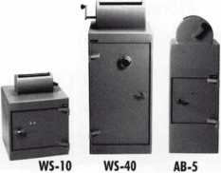

800-253-1267

114 S. Delsea Drive, Suite 3 856-863-1186

Glassboro, NJ 08066 Fax 856-863-1208

IN-STOCK...MORE SAFES

***FREE Freight Program***

***(30 States)***

AMSEC FireKing

Gardall **hayman**

MEILINK **y/CTOK**

**TURPI tO**

**WHOLESALE SERVICE**

800**-**848-9790

You need it When?

**How about now!? :-)**

ClearStar © orkV

Another Special  
Value-added Benefit to your

ALOA Membership!

Click here

*>L*

[www.clearstar.com](http://www.clearstar.com) / ALOA

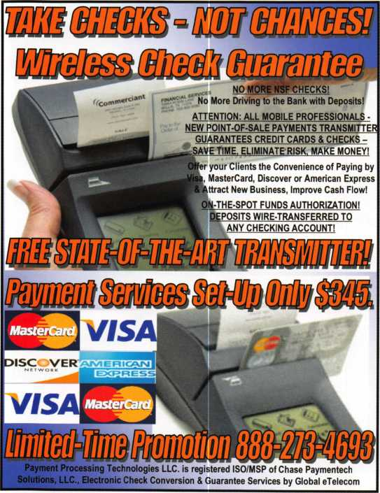

**Professional Business Products**

Invoices Tags *Call for a free*

Checks Key Fobs *brochure and samples*

**Business Magnets 1-800-355-6322**

Cards Labels [www.pbp2000.com](http://www.pbp2000.com)

Keynotes • October 2007

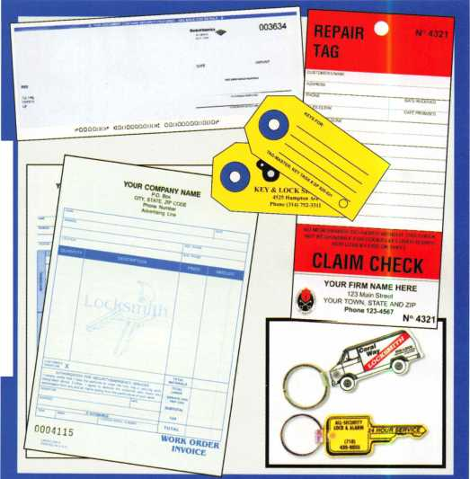

**BRIGHTEN** YOUR  
FUTURE. **HIGHLIGHT**YOUR SUCCESS!



**SAFE & VAULT**

**TECHNICIANS ASSOCIATION CONVENTION & TRADE SHOW**

2008

Highlight your path to the future with the latest technology the industry has to offer to safe technicians at SAFETECH 2008. Exposure to today’s top safe distributors and manufac­turers is absolutely crucial to making good purchasing and sales decisions. Additionally, time is of the essence when it comes to education. New de­velopments spring up each year, making top-notch safe

classes a necessity in our ever-changing environment. SAFETECH classes cover sub­jects related to the installation, maintenance and operation of sales and vaults at levels from novice to expert. The only chance to get world-class edu­cation and meet with the in­dustry’s top distributors and manufacturers is at the 2008 Safe & Vault Technicians Convention & Trade Show.

**SAFETECH 2008**

March 31-April 5, 2008  
Bahia Resort Hotel  
San Diego, California

[www.savta.org](http://www.savta.org) *214.819.9771

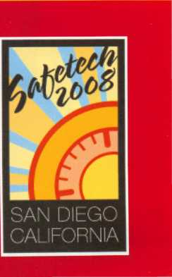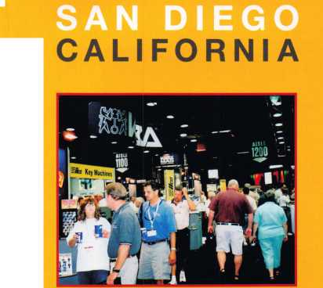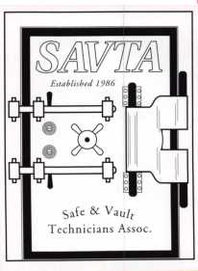

Associated Locksmiths of America announces the Postmaster General now regards “Bump Keys” as non­mailable lockpicking tools

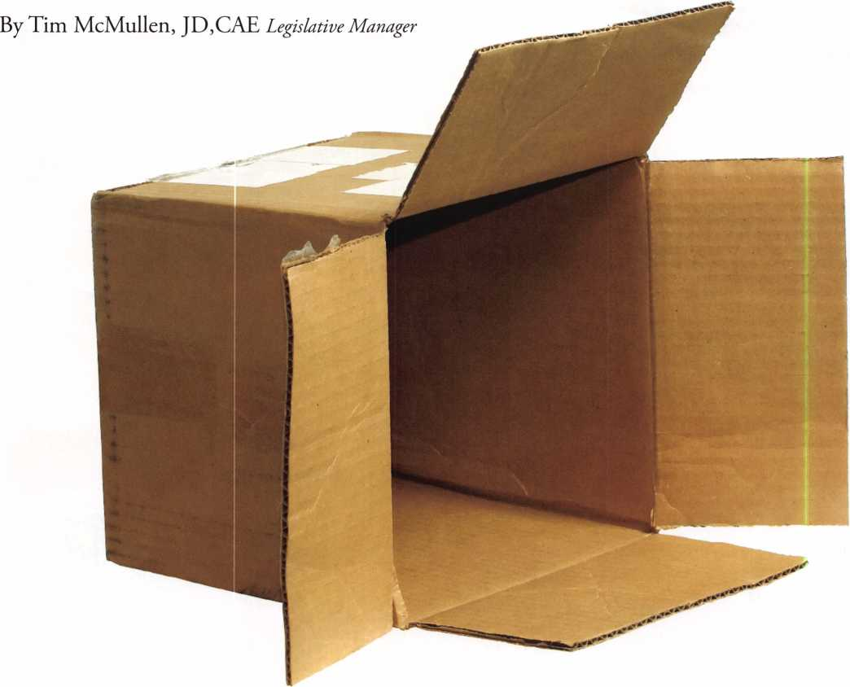

Keynotes • October 2007

Advises public to install high security locks to prevent break-ins from “Bump Keys”

The Associated Locksmiths of America, Inc. (ALOA) worked closely with a num­ber of physical security manufacturers to make the mailing of “bump keys” a fed­eral crime.

The Postmaster General recently issued an official opinion declaring that “bump keys” fall under the definition of “lock- smithing devices,” which are considered to be non-mailable under current federal law.

The law (39 USC 30 §3002a) makes it a crime to mail “locksmithing devices” to anyone other than a lock manufacturer or distributor, a bona fide locksmith, a bona

fide repossessor or a motor vehicle manu­facturer or dealer. Now, if an individual (or company) is caught mailing a “bump key” they could be fined up to $ 1,000 or imprisoned up to one year, or both (18 USC 83 §1716A).

ALOA recently published a Press Release for consumers who are concerned whether their locks or premises are sus­ceptible to being compromised through the use of “bump keys”. ALOA recom­mended they consult an ALOA Certified Locksmith (CRL, CPL, CML) and ask for recommendations for improving security.

Keynotes • October 2007

ANNUAL MEETING OF THE MEMBERSHIP OF  
THE ASSOCIATED LOCKSMITHS OF AMERICA, INC.

**Draft**

The annual Membership Meeting was held in the Grand Ballroom of the Westin Charlotte in Charlotte, North Carolina on July 27th, 2007, called to order at 10:50 AM by President Robert Mock and was followed by the Pledge of Allegiance. A moment of silence was then ob­served.

The following Board members were in attendance: President-Robert E. Mock; Secretary John W. Soderland, CML, CMST, CIL; Directors Keith E. Whiting, CML, CFL; William J. Smith, RL; Guy M. Spinello, RL; Tom Foxwell; Bob DeWeese, CML, CPS; Julie McCluney, CRL; Greg Parks, CRL; C.D. Lipscomb, CML, CPS; Tom Gillingham, CML, CPS; Ken Kupferman, CML, CPS; Hans Mejlshede, CML; Dan Floeck; Clyde T. Roberson, CML, AHC, CPP; Trustees- William Young, CML, CPS; Randy Simpson, CML; John Greenan, CML, CPS. Ex­ecutive Director- Charles W. Gibson, Jr., CAE was also in attendance.

President Mock introduced members of the ALOA Board and Staff.

President Mock gave a report and overview of his activities over the past year.

The Secretary and Directors in turn gave reports relating to their duties, travels, and activities since the last Board meeting.

Executive Director Bill Gibson presented his report on the state of the association.

He also reported action was being taken to increase and retain membership. A questionnaire has been distributed and analyzed in order to im­prove member services and benefits.

Bill Young gave a detailed report on the progress and future of the NASTF program to disburse automotive key codes to qualified locksmiths. Bill Young gave a report on the ALOA Open Golf Outing.

Bill Young, Vince Forman, Tom Demont, and Gordon Racine presented a check to the ALOA Scholarship Foundation in the amount of $13,000.00 on behalf of the ALOA Open, of which ASSAJABLOY is the primary benefactor.

President Mock presented the President’s Award to David O’Toole, President, European Locksmith Federation.

ALOA Director of Training & Certification, David Lowell, CML, CMST, announced that the 2007 ACE Instructor of the Year Award is being presented to Harry Sher, CML, CPS. Since Harry was unable to attend the membership meeting he will be presented with the award at the ALOA Headquarters in Dallas at an appropriate time.

President Mock announced the results of the recent election, which were:

President: Ken Kupferman, CML, CPS Southwest Director: Greg Parks, CRL Southwest Director: Gordon Racine, CML North Central Director: Guy M. Spinello, RL North Central Director: William J, Smith, RL Southeast Director: Tom Gillingham, Jr., CML, CPS Southeast Director, Steve Myslik, CRL

President Mock recognized the departing board members, and thanked them for their services on behalf of the association.

Departing Board Members are:

John Greenan, CML, CPS Julie McCluney, CRL

President Mock Presented Life Membership to David Killip President Mock introduced the new Board Members.

President Mock presented the gavel to President Elect Ken Kupferman.

Ken Kupferman presented a Past President plaque and Life Membership card to Robert Mock.

M/M: Don O’Shall#14049/William Fadgen#23525 ” To accept the minutes of the Annual Membership Meeting of July 13th, 2006”-PASSED M/M: Tom Demont#2809/Bill Timmann#23288 “ To accept the minutes of the Election Meeting of June 8th, 2007”-PASSED

M/M: Peter Sarailian#7404/Jerome Andrews#11912” To destroy the 1007 Election Ballots”-PASSED The meeting was adjourned at 11:55 AM

John W. Soderland, CML, CMST, CIL Board Secretary

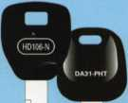

**EASTER LOCK & KEY** w 325-3535 /

USDVA

ILLINOIS

A-1 KEY & LOCK  
24HR SERVICE  
312-555-1234

DUPLICATION

PROHIBITED

**Professional Products for Professional Locksmiths**

**Smart Clone**

**For All Cloneable Keys... Including Ford, Infiniti & Toyota**

**Smart Clone Key Blanks**

**Largest Selection of Groovy Keys... Anywhere**

**Automotive**

**Transponder**

**Keys**

**JET HARDWARE MANUFACTURING CORP**

**800 Hinsdale Street, Brooklyn NY 11207**

**Displays and Key Assortments**

B49

**Precision Key Machines and Cutters**

AR1

**250 Bin**

**,cation**

%P0>£D

**Master Keying and Fine Duplication**

**View Our Complete Line of Professional Locksmith Hardware at**

**Jet**

**Exclusives**

ABC KEY  
USA

555-1212

**[www.jetkeys.com](http://www.jetkeys.com)**

**Uni Bow Neuter Bow Personal Line**

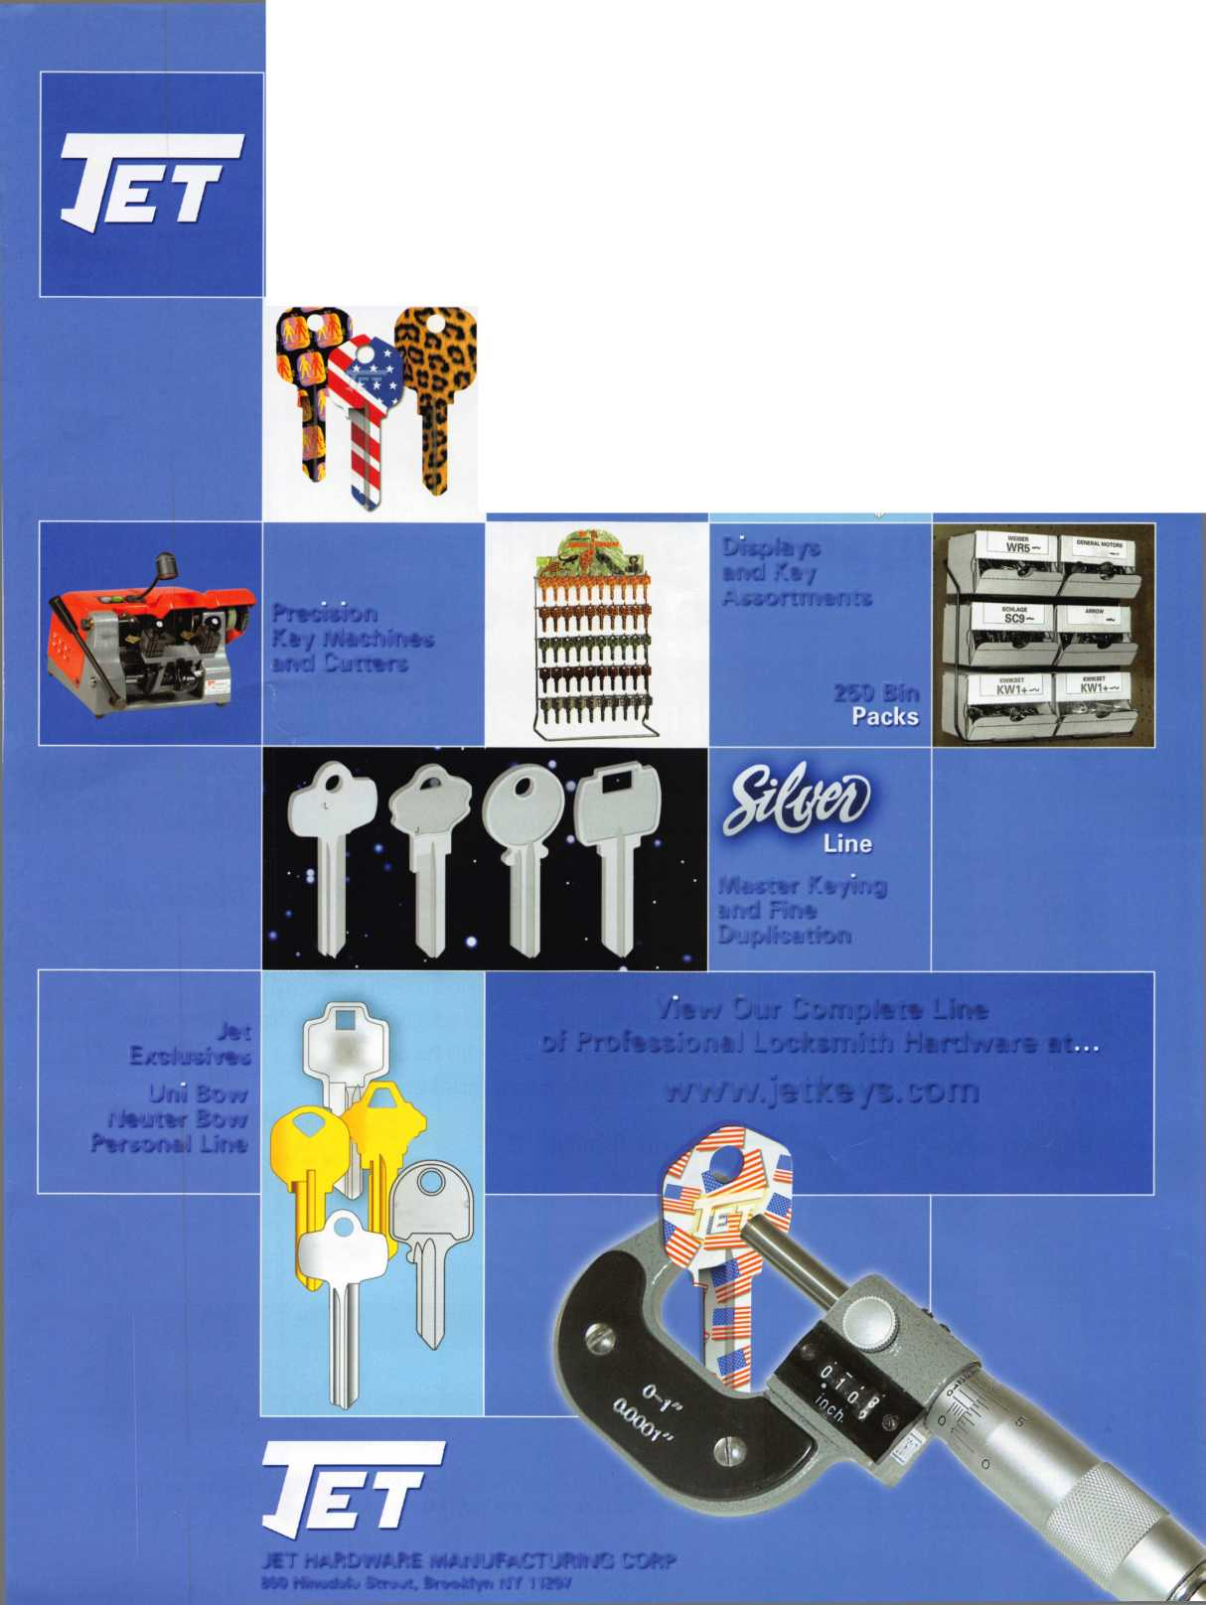

*Styles* & *Colors for Every Lifestyle*

* Recognized & Accepted by the TSA
* Security Window cannot be altered with a paper clip
* Security Window can only be reset by a person knowing the combination
* Zinc Die Cast Body (Not Brittle Plastic)
* Steel Shackle is virtually unbreakable

Security Window

O

**Red Window:**

Luggage has been searched.

O

**Green Window:**

Lock Not Opened.

Protected by U.S. Patents 6,877,345 and 7,007,521. The Design of the Lock is a Registered Trademark* of The Eastern Company.



**Security Products** A Division of The Eastern Company **A Proud Union Company. (S.E.I.U.)** 301 West Hintz Road | Wheeling, IL 60090 | Telephone: 800.733.8588 | Fax: 847.537.1881 **wvsnv.cclsecurity.com**

**TRAVEL SENTRY**

**APPROVED**

